**IM3080 Design and Innovation Project**

**(AY22/23 Semester 1)**

**Project Report**

**Title:** SOMA - Personality Test Mobile App

**Github:** <https://github.com/chongwei49/DIP-Group-6-Android>

**Submitted by:** (Group 6) Ang Jing Jing, Guerta Uno Gabriel Yap, Heng Zi Hui, Jocelyn Valencia Yoswara, Lee Chi Yan Audrey, Luo Chongwei, Muhammad ‘Arif Bin Abdul Malek, Vanessa Christy Chandra, Wu Hongrui

**Supervisor:** Mohammed Yakoob Siyal (Assoc Prof)

# **Table of Content**

1. **Background and Motivation**
2. **Project Overview**
3. **Objective**
4. **Feature Ideation and Prioritization**
5. **Feature Requirements**
6. **Product Pitch and Marketing Plan**
7. **Project Management**
8. **Review of Technology**
9. **Design: Theory, Evolution & Implementation**
10. **Conclusion and Recommendation**
11. **Appendices**

# **Background and Motivation**

Personality tests have always been a popular way among young adults to learn about themselves and also a way for others to gain a more in-depth understanding of their acquaintances. The genuine personality of a person is made up of significant, defining events in their life, together with a distinct genetic component exhibited by their temperament as young children. Each person develops their personality in their own unique way.

According to Psychology Today, more than $3 billion is spent annually on personality tests, and about 80% of Fortune 500 organisations use them to evaluate potential hires. A person's performance in school or in work can be accurately predicted by certain features, according to researchers. Although they are more frequently employed for private amusement, personality tests are used for research and job placement. A corporation could anticipate that certain occupations need a specific personality trait. The exam would be created to find that desired trait in employees, regardless of whether they hired a consultant or did it themselves.

While there are many online personality tests one can take, the mobile market for such tests have largely been unexplored, the few apps that do often become very popular among the targeted demographic. The group members were all very interested in exploring how personality tests’ algorithms were created and how we may innovate beyond simply taking the test. Thus, our group decided to develop our own personality test mobile software called SOMA to achieve these goals.

# **Project Overview**

SOMA: Personality Test Mobile App is a self-reporting application that measures personality traits based on answering several questions. These tests are regarded as objective because the test-taker cannot be influenced in any way by the app’s administrator. The results of these simple questions are then used to create a personality profile that provides a thorough analysis of the test actions, the taker's way of thinking, and unique personality. Soma provides 3 major tests that users can take everywhere, at any time: Personality Test, Love Language Test, and Career Test.

This product will be in the form of a mobile application that can be viewed from any type of smartphone device with and without an internet connection.

# **Objective**

Our project aims to create a mobile software application that conducts a personality test in order to provide university students with insights into their personality, love, and job archetypes. The main targeted demographic is NTU EEE and IEM students and the desired outcome is for the users to have a better understanding of their professional qualities, have an idea about how it could be applied in their professional life, and be able to network with similarly minded or compatible peers within the app network.

# **Feature Ideation and Prioritization**

The first step of our project is to specify the features of SOMA, its purpose, and how it can assist in resolving user issues. We create the features based on 4 main use cases:

1. A user doing an individual test (i.e. Personalities Test, Love Language Test, Career Test)
2. A user adding a new friend recommended by the system
3. A user doing a compatibility test together with a friend
4. A user receives the test result report and able to save it

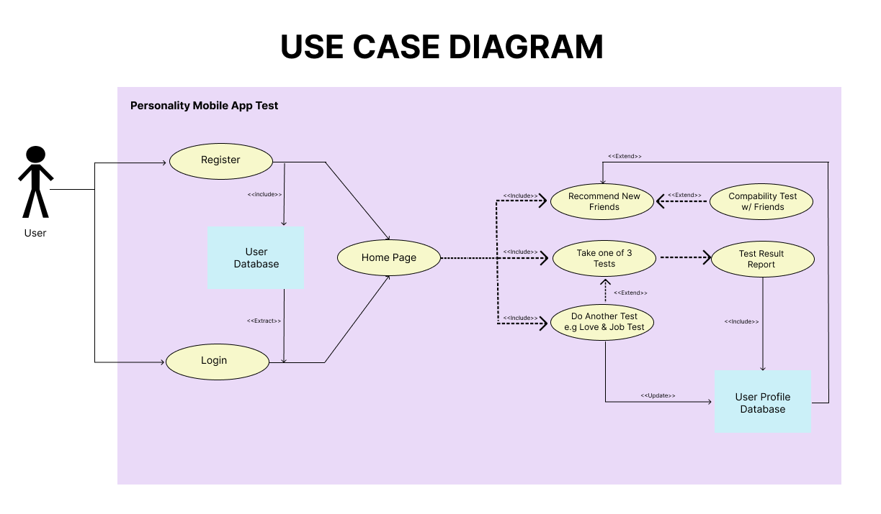

Fig 1. Use Case Diagram

Our group also made a Product Requirement Document to specify the requirements for our mobile app, including objective, features, functionality, behaviour, and success metrics. This document serves as a Soma Mobile App development roadmap - a guide for picking release milestones and priorities and organising the development of features around them. The initial Feature Ideation, Prioritization, and its Success Metrics can be shown in Table 1.

| **User Journey** | **User Story** | **Metrics to Target** | **Priority** | **Notes** |
| --- | --- | --- | --- | --- |
| 1. Log-In Page | | | | |
| (i) Sign Up Account | Users want an easy sign-up process to the app | No. of signed-up users | Must have | MVP: all NTU EEE and IEM Students sign up for this app |
| (ii) Log In | Users want the fastest log-in process | DAU, MAU, Retention Rate | Must have |  |
| 2. Home Page | | | | |
| (i) Dashboard | Users want to view all of the services offered by this app in one location. | - | Must have | This page is important to introduce the concept of this app |
| (ii) About App | Users want to get a better understanding of this app, in general, | - | Should have | In the form of a short paragraph |
| 3. Tests | | | | |
| (i) Binary choice questions (Yes/No) | Users want to know their personalities, love language, and career advice based on several questions asked | - | Must have |  |
| (ii) Report Landing Pages | Users want to know their personality report after doing the test | - | Must have |  |
| 3. Results & History | Users want to save the results of the personality test | - | Must have |  |
| 4. Find Friends | Users are looking for new people with similar personalities to connect | Average Session Length | Could have | Version 2 |
| 5. Recommendation | Users are interested in learning about other suggested pursuits, places, and interests that fit their personalities. | - | Will not have | Version 2 |
| 6. Profile | Users want to update their personal data or might want to delete their account | Churn rate | Must have |  |
| 7. Data Privacy Disclaimer | Developers want to make sure that the personal data collected from users only as permitted by law and if users have given their consent | - | Could have |  |
| 8. Notification | Users will be kept informed about various modifications to this app. | CTR | Will not have | Version 2 |

Table 1. Initial Feature Prioritization & Success Metrics

# **Feature Requirements**

The SOMA Mobile App Requirements that we gave top priority for this project are listed below. These features are part of minimum requirements for a decent experience using SOMA App or Minimum Viable Product (MVP).

1. Log-In Page

1.1. Log In

1.1.1. Data

* Email
* Password

1.1.2. Log In Button → Redirect to Home Page

1.1.3. Continue with Google → Redirect to Home Page

1.2. Create an Account

1.2.1. Data

* Email
* Name
* Password
* Date of Birth
* Gender

1.2.2. Sign Up Button → Redirect to Home Page

1. Home Page

2.1. Data Privacy Disclaimer

2.2. Welcome Back User’s Name

2.3. About

2.4. Start Now → Redirect to SOMA Tests Page

1. Service Navigation

3.1. Connect Friends

3.1.1. Based on Personality

3.1.1.1. Start Now Button → if the user hasn’t done Personality Test,

3.1.1.2. Friends Recommendation

3.1.1.2.1. User Profile Page Data

* User Name
* Email
* Age
* Gender
* Personality Avatar
* Trait Name
* Trait Description

3.1.1.2.2. Back Button → Redirect to Connect Friends Page

3.1.1.3. Refresh → refresh friends recommendation

3.1.2. Based on Love

3.1.2.1. Start Now Button → if the user hasn’t done Love Test

3.1.2.2. Friends Recommendation

3.1.2.2.1. User Profile Page Data

* User Name
* Email
* Age
* Gender
* Love Avatar
* Trait Name
* Trait Description

3.1.2.2.2. Back Button → Redirect to Connect Friends Page

3.1.2.3. Refresh → refresh friends recommendation

3.1.3. Based on Career

3.1.3.1. Start Now Button → if the user hasn’t done Career Test

3.1.3.2. Friends Recommendation

3.1.3.2.1. User Profile Page Data

* User Name
* Email
* Age
* Gender
* Career Avatar
* Trait Name
* Trait Description

3.1.3.2.2. Back Button → Redirect to Connect Friends Page

3.1.3.3. Refresh → refresh friends recommendation

3.2. Home → Redirect to Home Page

3.3. Profile

3.3.1. Data Header

3.3.1. User Data (Name & Username)

3.3.2. Profile Picture

3.3.2.1. Remove Current Photo

3.3.2.2. Choose From Library

3.3.2.3. Take photo

3.3.2.4. Cancel → Redirect to Profile Page

3.3.2. Results

3.3.2.1. Personality Test

3.3.2.1.1. Start Now Button → if the user hasn’t done Test

3.3.2.1.2. Personality Type and Trait Name

3.3.2.1.3. View History Page

* Latest Personality Type, Trait Name, & Description
* Latest Date of Test
* List History of Personality Test Result & Date of Test
* Back Button → Redirect to Results Page

3.3.2.2. Love Test

3.3.2.2.1. Start Now Button → if the user hasn’t done Test

3.3.2.2.2. Love Trait Name

3.3.2.2.3. View History Page

* Latest Love Trait Name & Description
* Latest Date of Test
* List History of Love Test Result & Date of Test
* Back Button → Redirect to Results Page

3.3.2.3. Career Test

3.3.2.3.1. Start Now Button → if the user hasn’t done Test

3.3.2.3.2. Career Trait Name

3.3.2.3.3. View History Page

* Latest Career Trait Name & Description
* Latest Date of Test
* List History of Career Test Result & Date of Test
* Back Button → Redirect to Results Page

3.3.3. Settings → to update user’s profile

3.3.3.1. Data

* Name
* Email
* Date of Birth
* Gender

3.3.3.2. Save Button

3.3.3.3. Log Out → Redirect to Log-In Page

1. SOMA Tests

4.1. Personality Test

4.1.1. 25 Yes/ No Questions

4.1.2. Home Symbol Button → Redirect to Home Page

4.1.3. Personality Test Result

4.1.3.1. Personality Type

4.1.3.2. Personality Avatar

4.1.3.3. Trait Name

4.1.3.4. Trait Description

4.2. Love Test

4.2.1. 10 Yes/ No Questions

4.2.2. Home Symbol Button → Redirect to Home Page

4.2.3. Love Test Result

4.2.3.1. Love Avatar

4.2.3.2. Trait Name

4.2.3.3. Trait Description

4.3. Career Test

4.3.1. 10 Yes/ No Questions

4.3.2. Home Symbol Button → Redirect to Home Page

4.3.3. Career Test Result

4.3.3.1. Career Avatar

4.3.3.2. Trait Name

4.3.3.3. Trait Description

4.4. Back Symbol Button → Redirect to Home Page

# **Product Pitch and Marketing Plan**

Our initial target of users for SOMA App will be NTU EEE and IEM students. We made a Product Pitch Document to give a brief overview for our users about SOMA App, benefits and services provided by SOMA App, objective of our app, target market, how SOMA App will solve users’ problem, what makes SOMA App different with other app, scope of success, and marketing plan.

# **Project Management**

For project management, we initially used Google Drive and Google Sheet for resource sharing and task tracking via a crafted log. Later on, as our task load increased, we opted for Trello, a free project management software for easier tracking of tasks. We specifically utilised Kanban boards to divide the tasks among different teams for the most efficient task tracking.

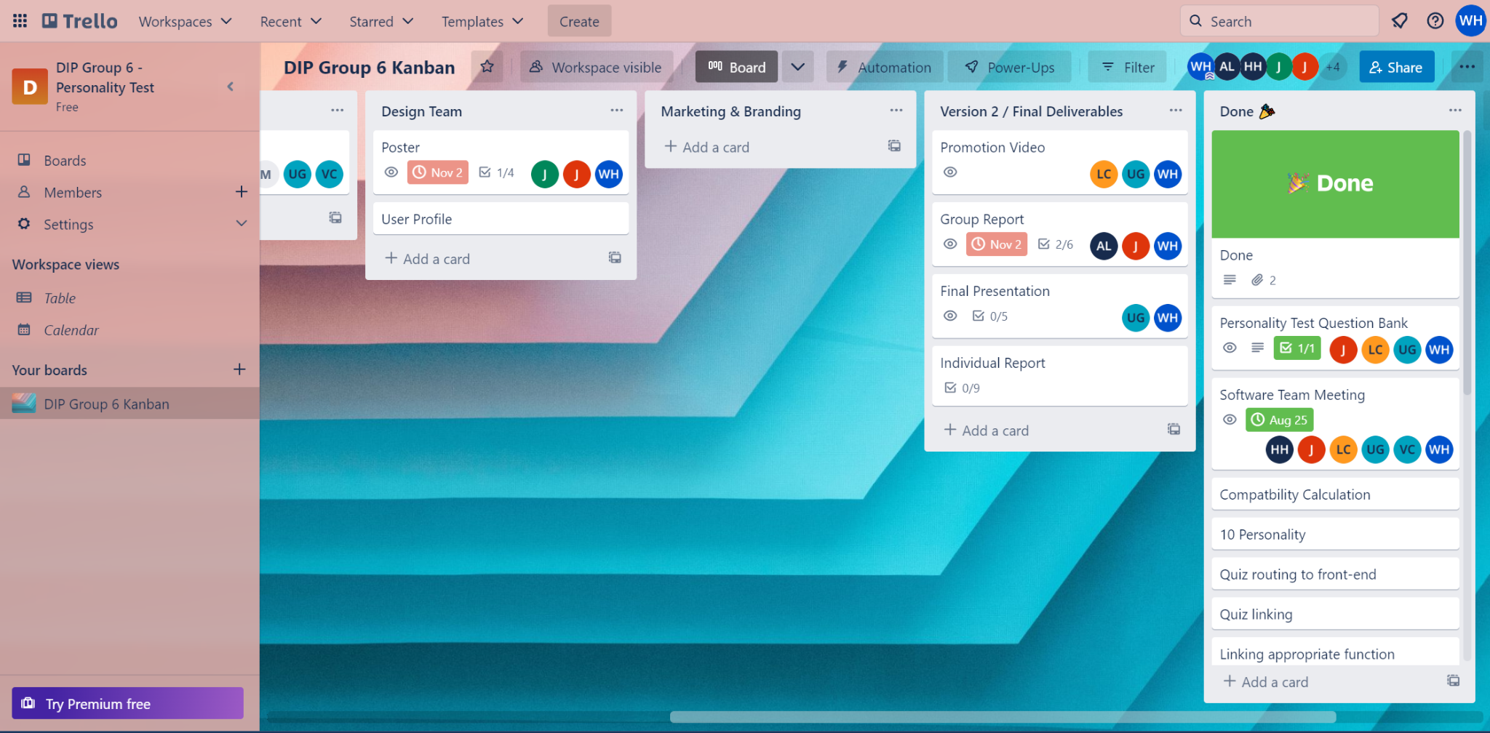

Fig 2. Project Kanban on Trello

# **Review of Technology**

When starting the project, we wanted to base our technologies on the tools we learnt during IM2073: Introduction to Design and Project. And to further refine the project, we also equipped additional tools that we learnt to utilise throughout the project duration.

When designing our interfaces, we utilised a variety of design software. Firstly, we made use of Photoshop to create the mood board and icons, which will provide us with the overall theme of the application. Afterwards, we used Figma to replicate buttons and other UI details accurately for the first version of the wireframe. However, we moved on to use Adobe XD to create the revised version of our wireframe. The reason for the change is to improve efficiency as Adobe XD allows us to export drawables directly into Android Studios, where we work on the application.

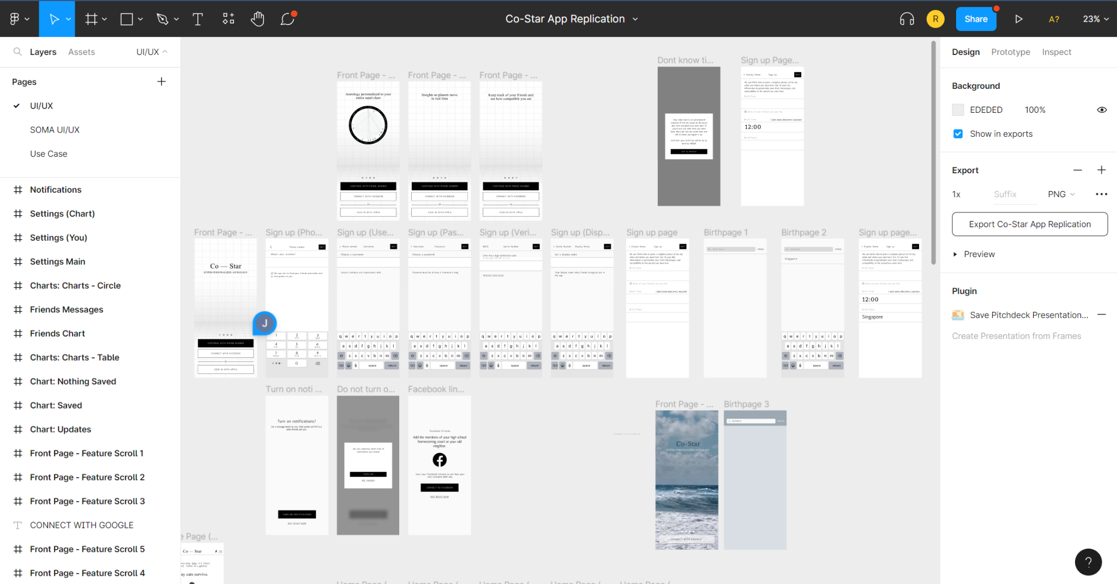

Fig 3. Figma Design Page (Version 1 App Replication)

Fig 4. (Adobe XD Screenshot)

For the development platform, we decided to utilise Android Studio for its ease of wireframe planning and function routing.

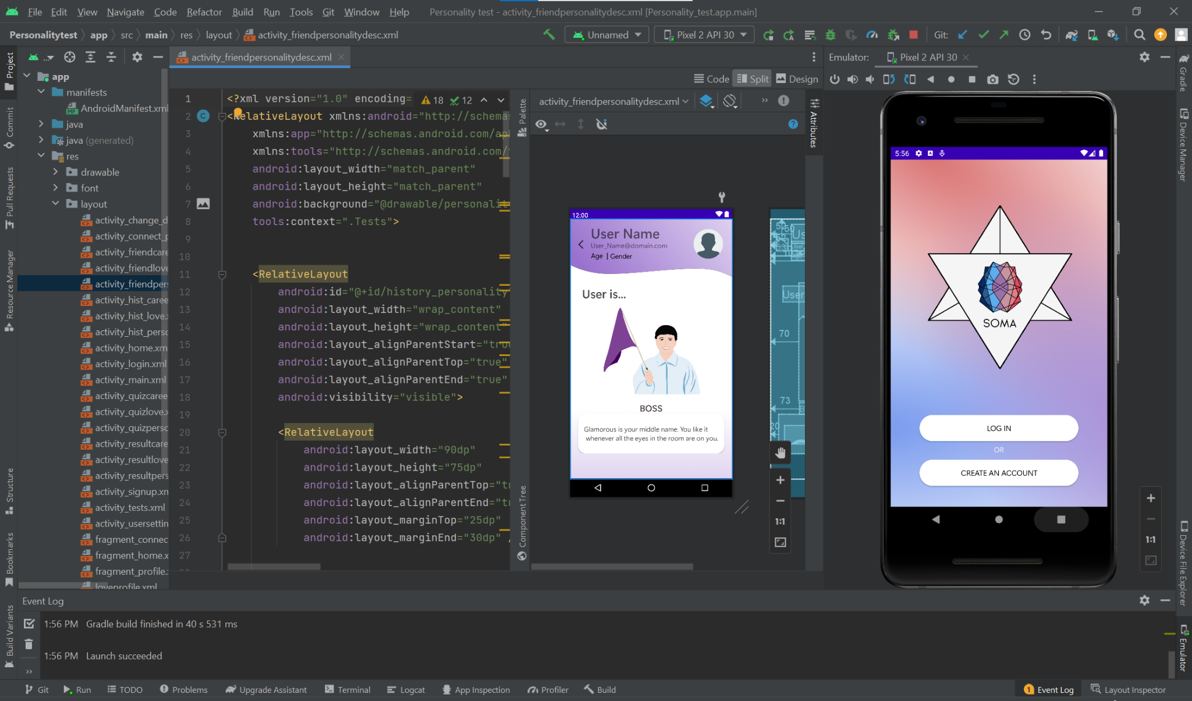

Fig 5. Android Studio Development Environment

In terms of building our app’s database and API, we decided to utilise MySQL to construct the databases and Java SpringBoot to build the REST API of our app. With SpringBoot, we can easily build microservices that can start small, easily tested, and deployed. It comprises of data models, services, repositories, and controllers that able to send a HTTP Response with message and status code.

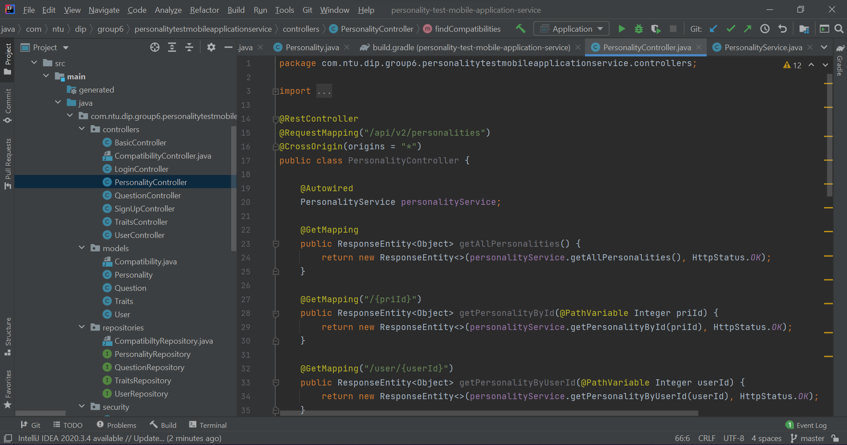

Fig 6. Code screenshot

For hosting of our databases, we initially employed Amazon Web Services, however, due to the charged subscription of the service, we later switched to Heroku, a free alternative for API deployment and database hosting (utilised the ClearDB MySQL add-ons with storage size of 1 GB, 10 connections at maximum at the same time, nightly backups, and production ready).

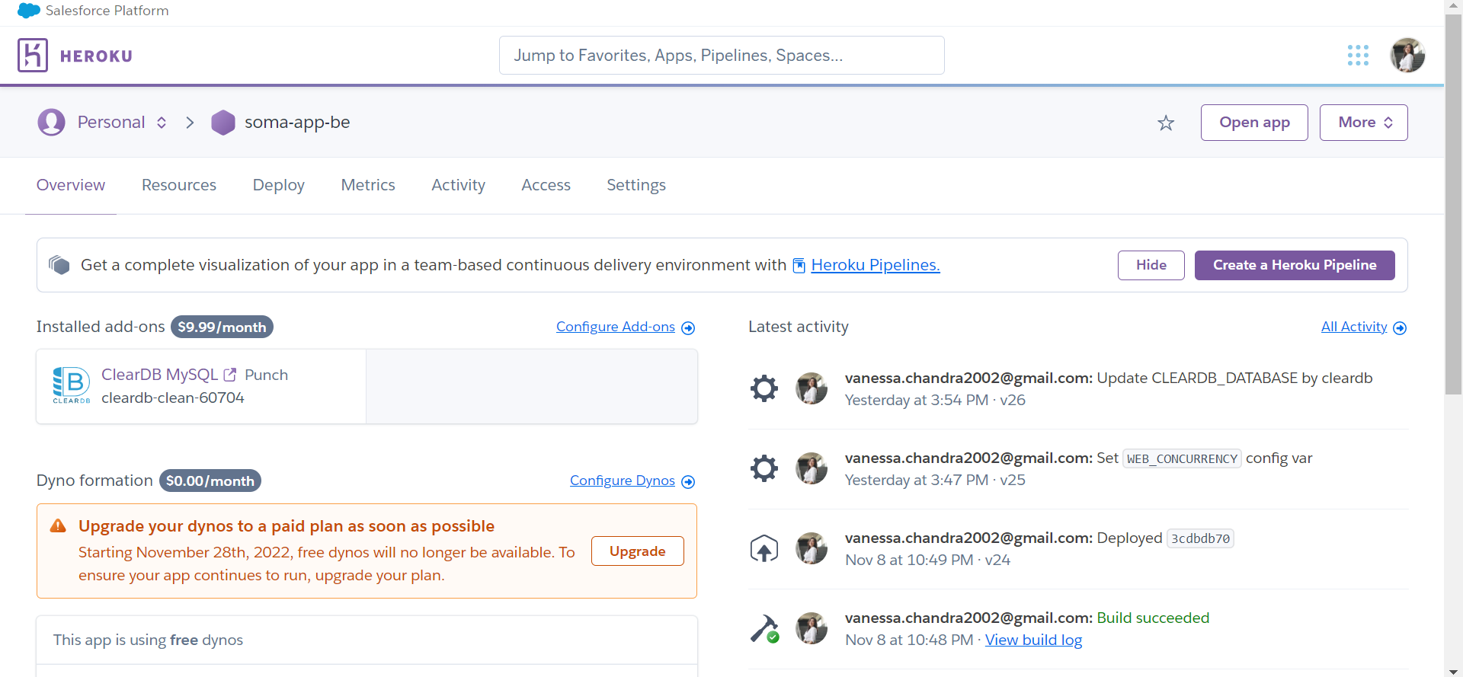

Fig 7. Heroku Services

For code sharing, we utilised Github and Git for quick and easy updates.

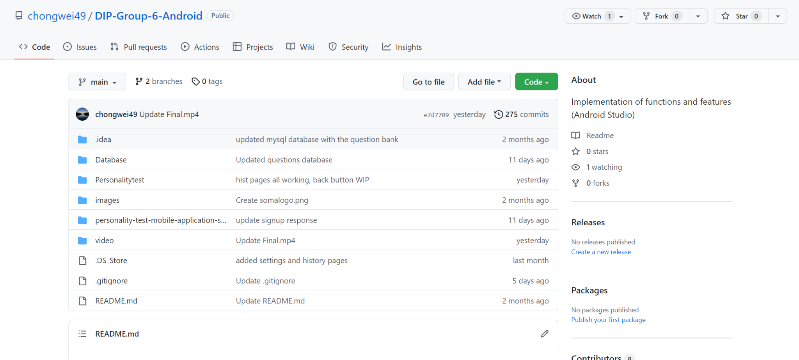

Fig 8. Android Studio Code Github Repository

# **Design: Theory, Evolution & Implementation**

### **Initial Development**

During Version 1 development of our application, the front-end team focused on replicating the User Interface element of the popular horoscope application “Co-Star”; By replicating its wireframe, we determined a few main sections of the UI feature we wish to retain for the final products, these are:

1. User Main page
2. Tests and Results page
3. User Profile Page
4. Friend & Recommendation page

Our team was heavily inspired by our reference application, “Co-Star” as it resonates with our goal of having a simple and intuitive application. We were able to come up with the user flow through the features of the application based on the existing application.

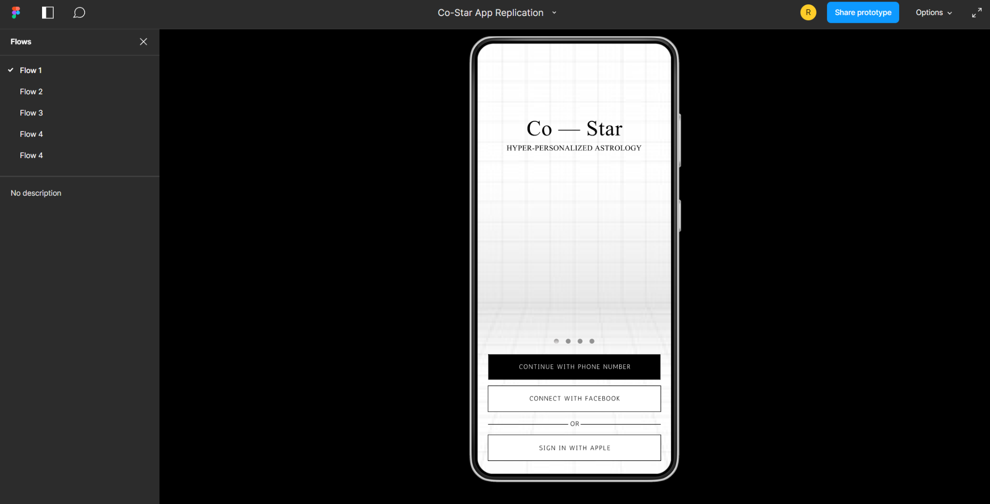

Fig 9. Version 1 App Figma Flow Demonstration

The user will be required to be prompted to take the personality tests in order to have personalised results based on their input responses. Results are required to further use features of the application, such as the networking features that are incorporated. We wanted to utilise the networking opportunities as the main reusability of the application.

### **Function**

We modelled the core function of our app, i.e. personality test, after another popular personality software that just came out recently named “Dimensional”. We wish to create a software where users are able to have a holistic evaluation of their traits without having to go through the hassle of going through different platforms.

In designing the function, we decided to deploy three different tests covering three aspects that are most relevant to a university students’ life, these are:

1. Personality Test
2. Love Test
3. Job test

For the database, we utilised 4 tables to represent the Users, Personalities (record of user personality results), Traits (to map each trait with trait name and description), and Questions. The structure of the database and examples of each table can be seen in the figure below.

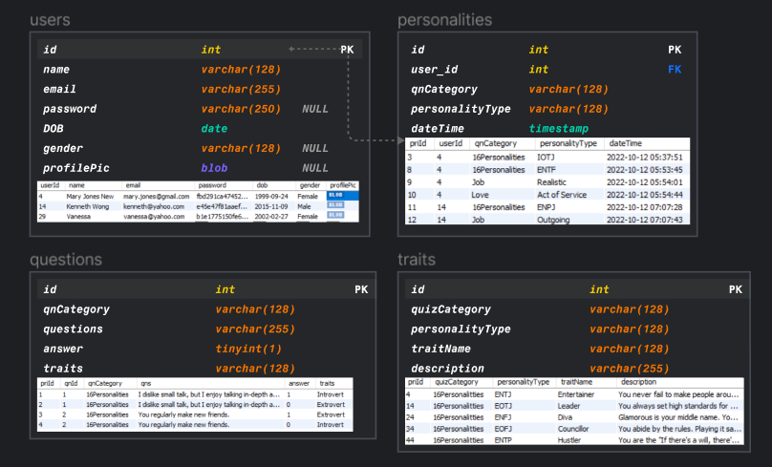

Fig 10. Database Design

To support the backend services, we utilised the REST API services as they are lightweight, independent, scalable and flexible. For each table entity in the database, it is represented by one object model in the backend service. Each object model has its own repository connected to the database entry, and here we utilised the CrudRepository interface from Spring Framework to make the searching and indexing process much easier. There are also services that consist of methods which utilise the repository abstract function (i.e. *userRepository.findAll()*). Lastly, the part that makes the whole REST services to be “alive”, the controller, that serves the endpoints with some services and returns the HTTP Response comprises messages and HTTP status code.

Some important feature that requires the API service:

1. **Sign Up**

During the signup process, the client will send a POST Request to the server with a JSON Body consisting of name, email, password (raw plaintext), date of birth, gender, and profile picture. Then the server will receive this request body, and it will first hash the plaintext password before storing the data to the database. The hashing algorithm is “SHA-512” and it uses a salt (in this case, we use the Base64 string of user unique email and password) to ensure that the hashed password output is unique. After the hashing process, the backend can securely store the user information to the database. Once it successfully stores the user object, it will return a response of the user object with 200 OK status.

1. **Login**

During the login process, the client will first encode the user email and password with Basic Authentication method. It will then create a GET Request to the server with the Basic Authentication string (i.e. *Basic dmFuZXNzYWNAZ21haWwuY29tOmhlaGVIRUgxMjIzIQ==*) as the Authorization Header. On the server side, it will first decode the authorization header into user email and raw password and validate the user by hash the given password and compare it with the stored user email’s password from the database. Once it is validated, it will return a response of the user object to the client with a 200 OK status code.

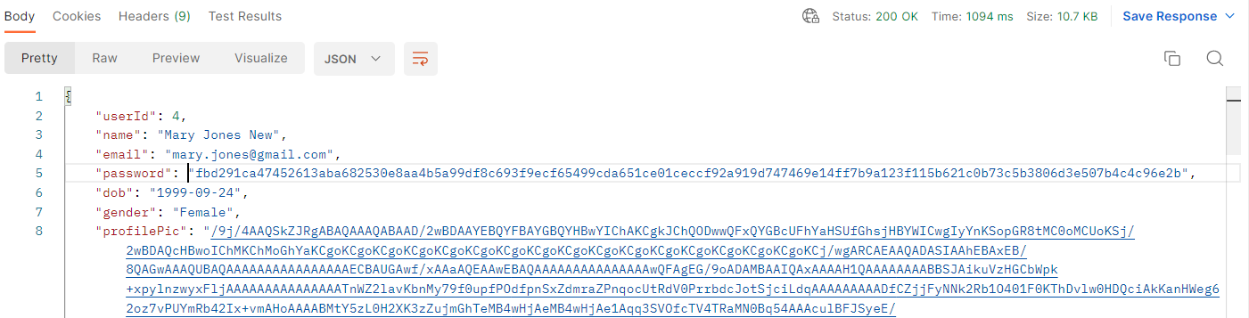

Fig 11. Sign Up and Login Response

1. **Store User Test Result**

During the record process of the user test result, the client will do the calculation based on the user answers and trait mapping. After obtaining the user trait (i.e. INFP, Physical Touch), it will create a POST Request to the server with a request body of question category, personality type, datetime. The server will store this personality object data to the database, and will return a response of a JSON object composed of personality type, trait, description for the display purposes in the UI side, and a 200 OK status code.

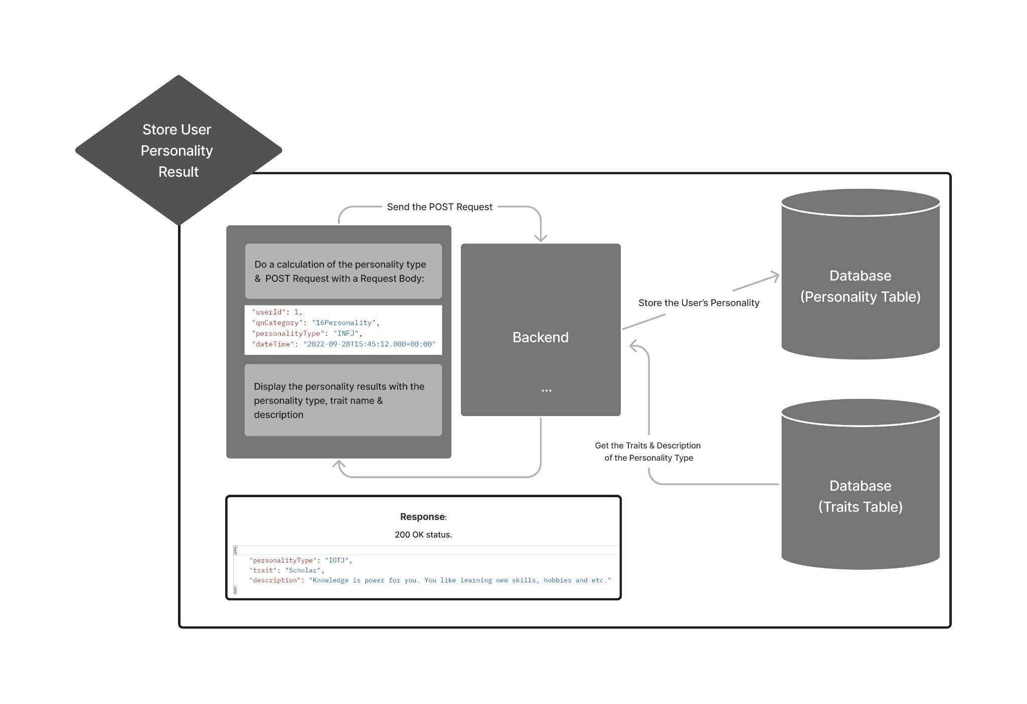

Fig 12. Store of User Personality Result Diagram

1. **Get Users with Similar Compatibility**

During the process of finding users with similar compatibility, the client will do a GET Request with a path variable of the user personality type. The server side will do querying and indexing from the other user's latest test result records. For ease of development purposes, in finding compatible friends based on personality type, we are comparing users that have minimum 2 similar traits). The server will send the array of user objects and a 200 OK status code.

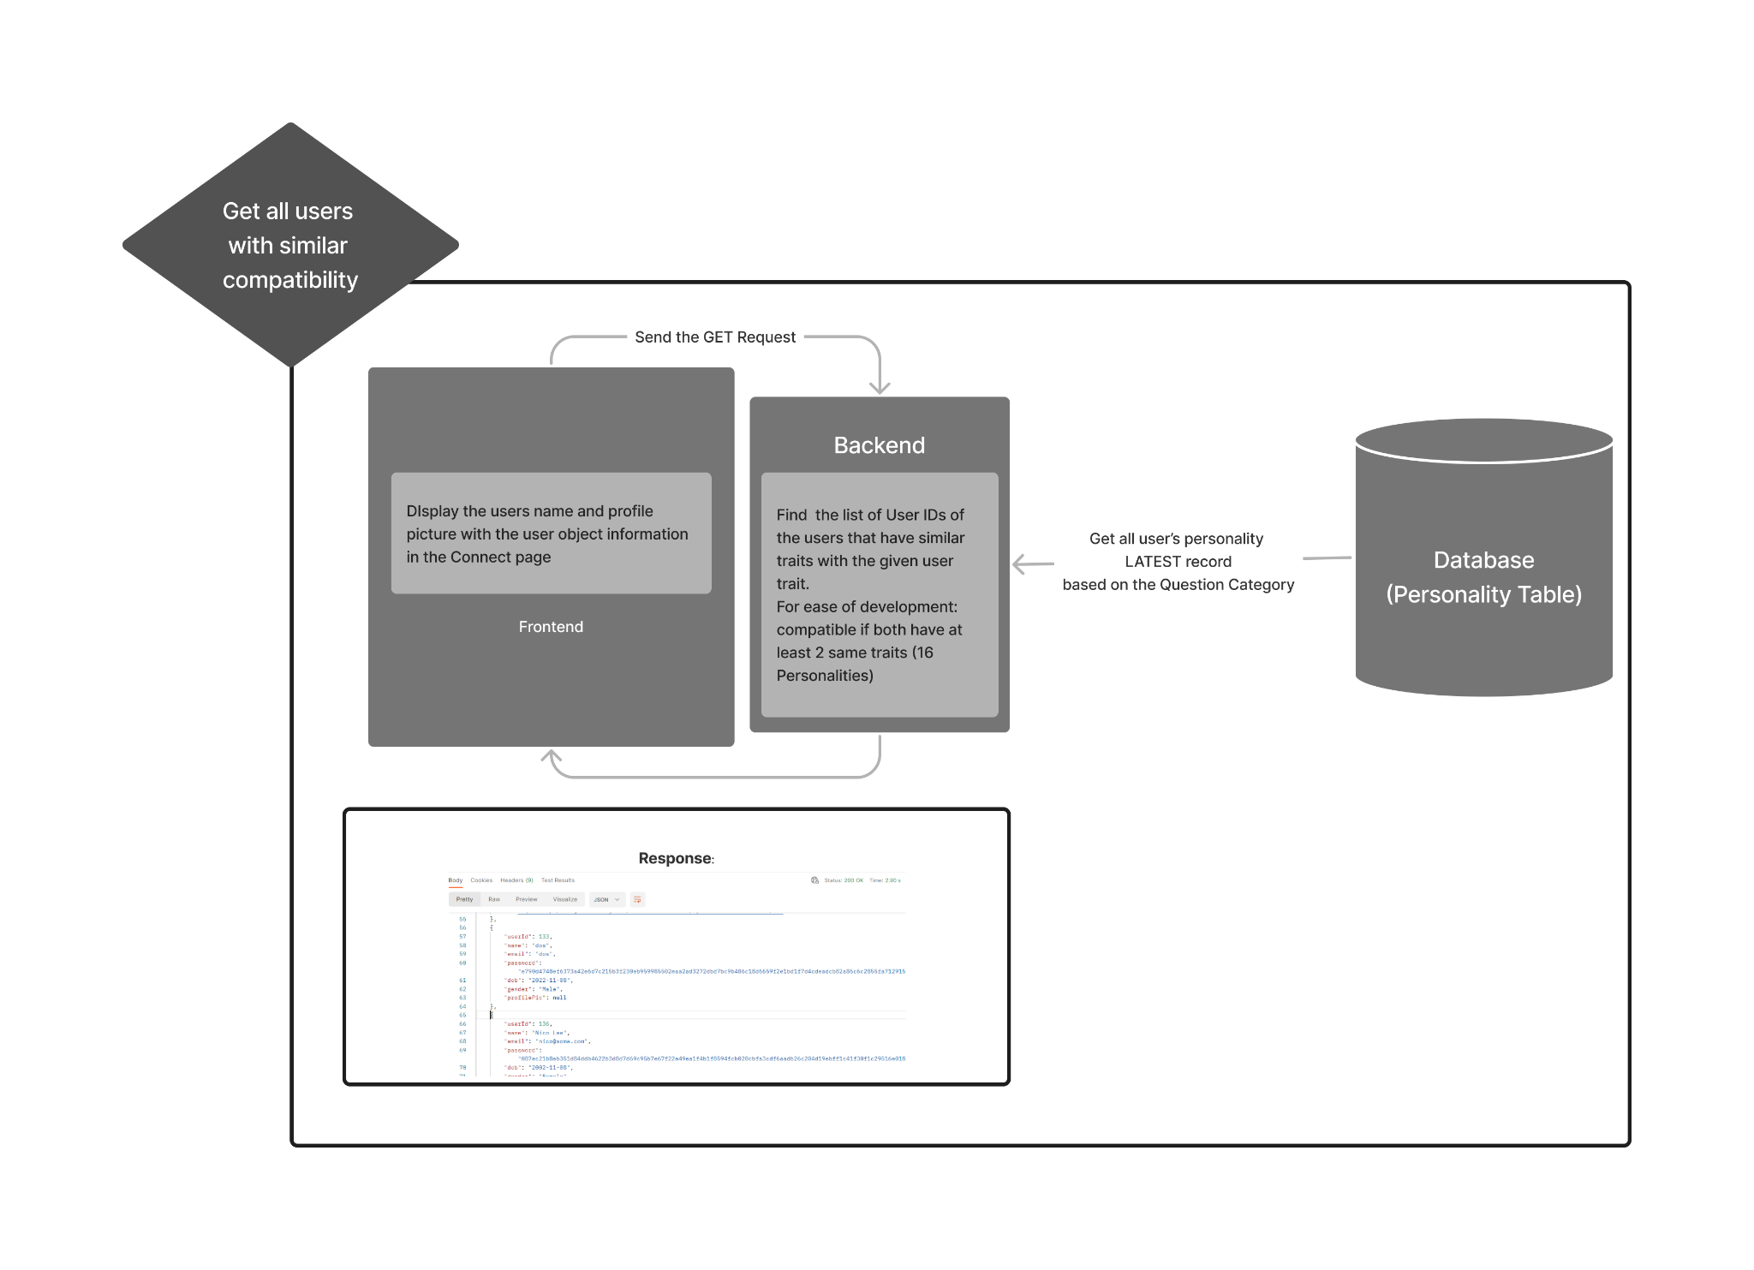

Fig 13. Find Compatible Friends Diagram

### **Evolution, Final Design & Implementation**

Our app has undergone numerous reviews in terms of user interface and function as the Version 1 of our app consists mainly of replication of our selected app case study. After recognising that the UI and look of our application will be too simple after the expansion of the features of our application, we developed an entirely unique set of designs from scratch. Our first step would be to come up with a new mood board.

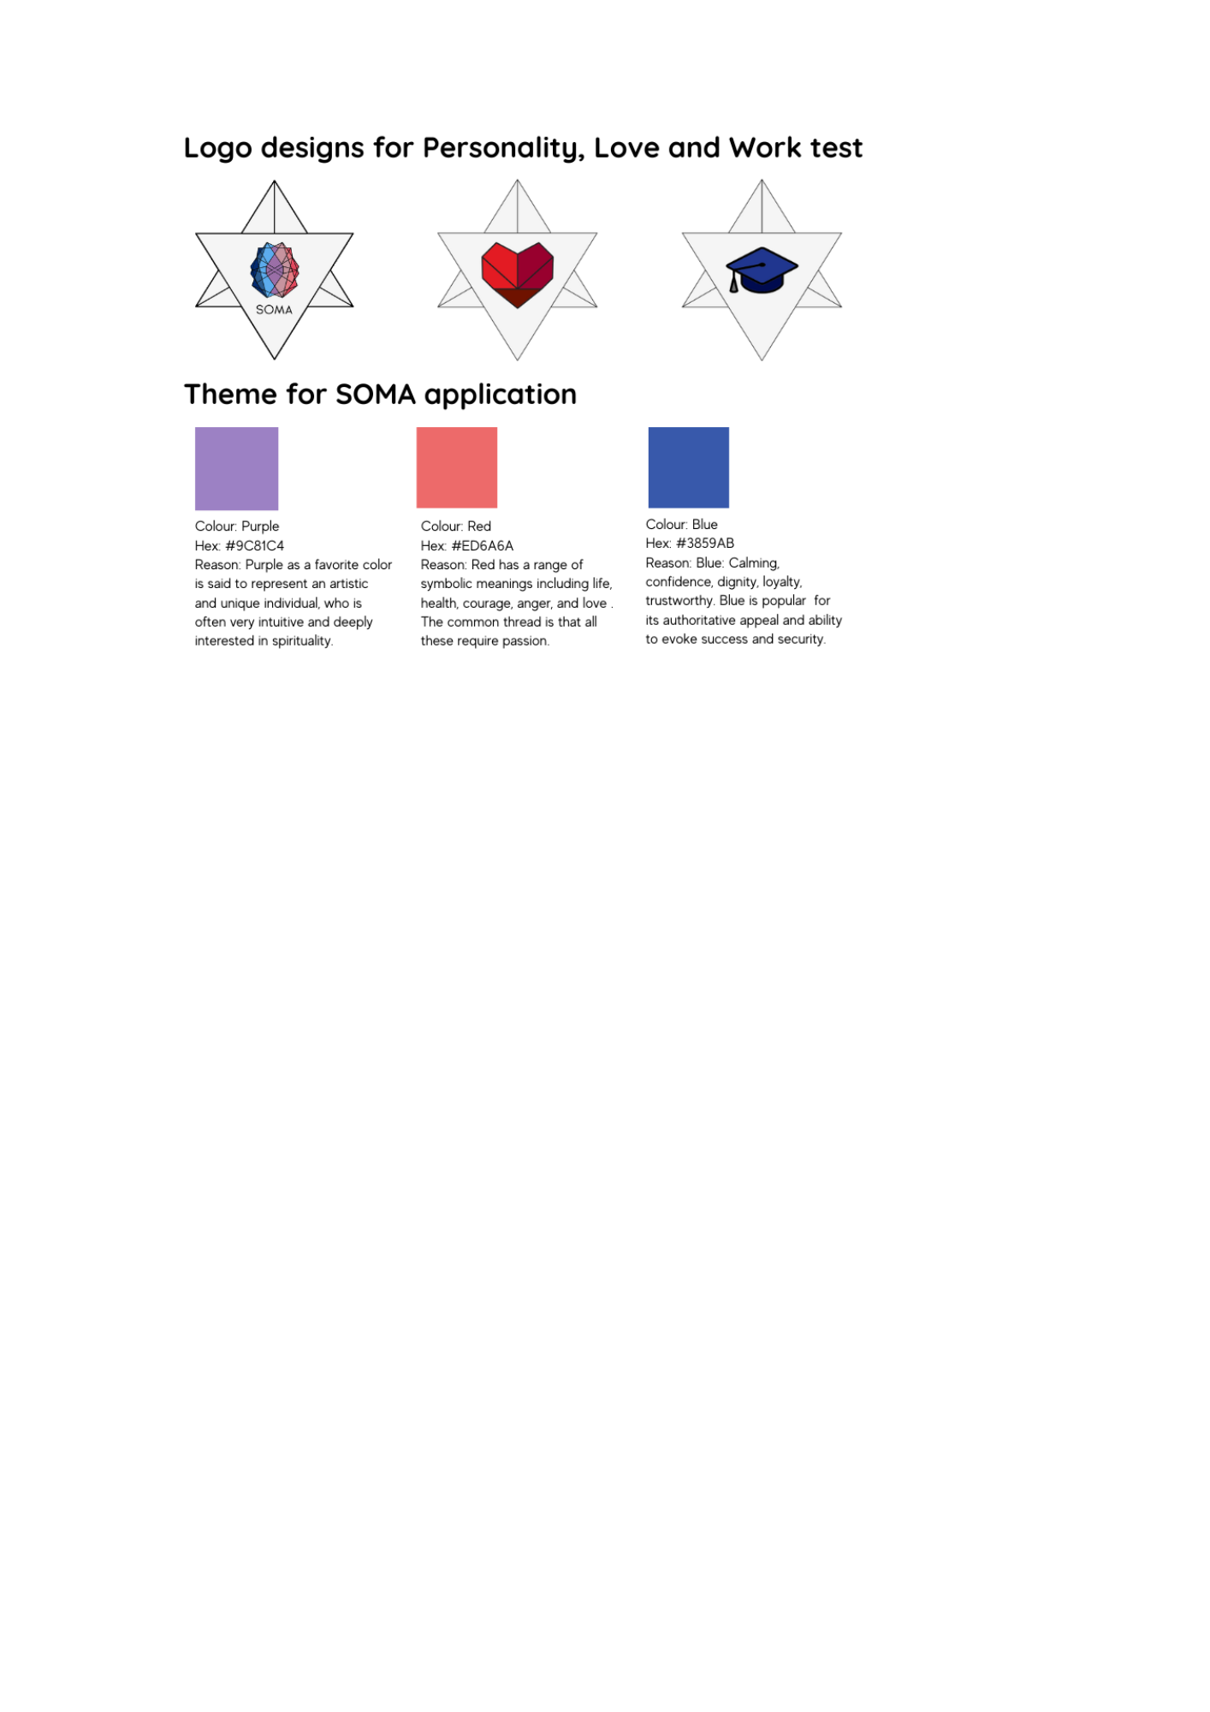

Fig 14. Summary of Icon Design & Mood Board

Specifically, we have decided to design three separate colour palettes for the three tests, as they aim to evoke different feelings from the users. And thus, our team assigned these colours to the tests:

1. **Personality Test - Purple**

A more neutral, evocative purple-based colour scheme that reflects the personality test nature. Purple has been linked to an inward thinking individual, which suggests individuality and introspection, thus being apt for the personality test. It is an exercise in exploring the human psyche and thus has certain elements of mystery and intrigue to it.

Purple the primary colour used in the middle of the logo as the love test and job test branches out on the main personality of the individual.

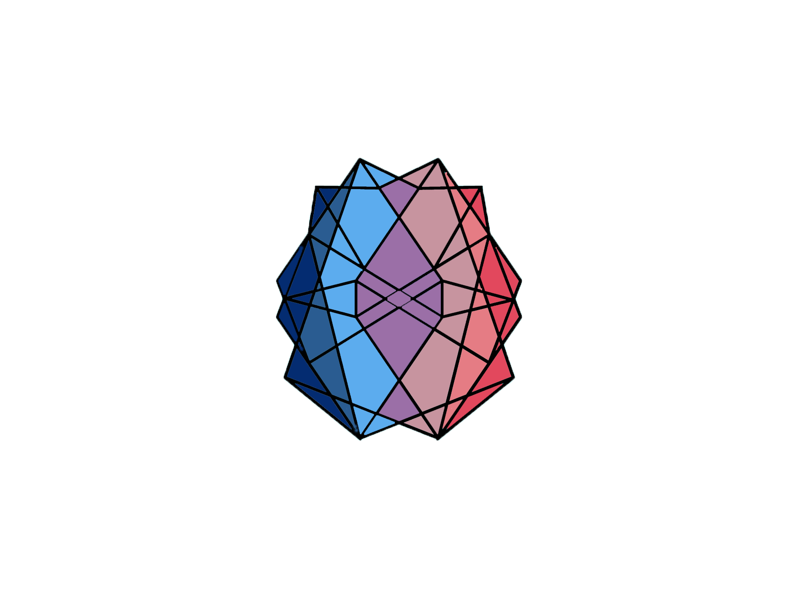

Fig 15. Personality Test Logo

1. **Love Test - Red**

A passionate, bright warm red colour scheme that reflects the love test nature. Red has been linked to the romantic aspect of human emotion and is often deemed as a daring and bold colour, which is suitable for the love test. It is an exercise in exploring the love language of the users and we aim to invoke the feeling of love with the warmer colours.



Fig 16. Love Test Logo

1. **Job Test - Blue**

A colder, more professional blue colour scheme that reflects the job test nature. Blue has been linked to calmness and serenity, which is often important in the workplace as one is required to keep their composure, thus being suitable for the job test. It is an exercise in exploring the professional aptitude of the users, and we wish to invoke a corporate, professional feeling with the users with the darker, colder scheme tone.



Fig 17. Job Test Logo

By fixing on the 3 main colours, we are able to come up with the main background being a fusion of these colours.



Fig 18. Fusion of Colours

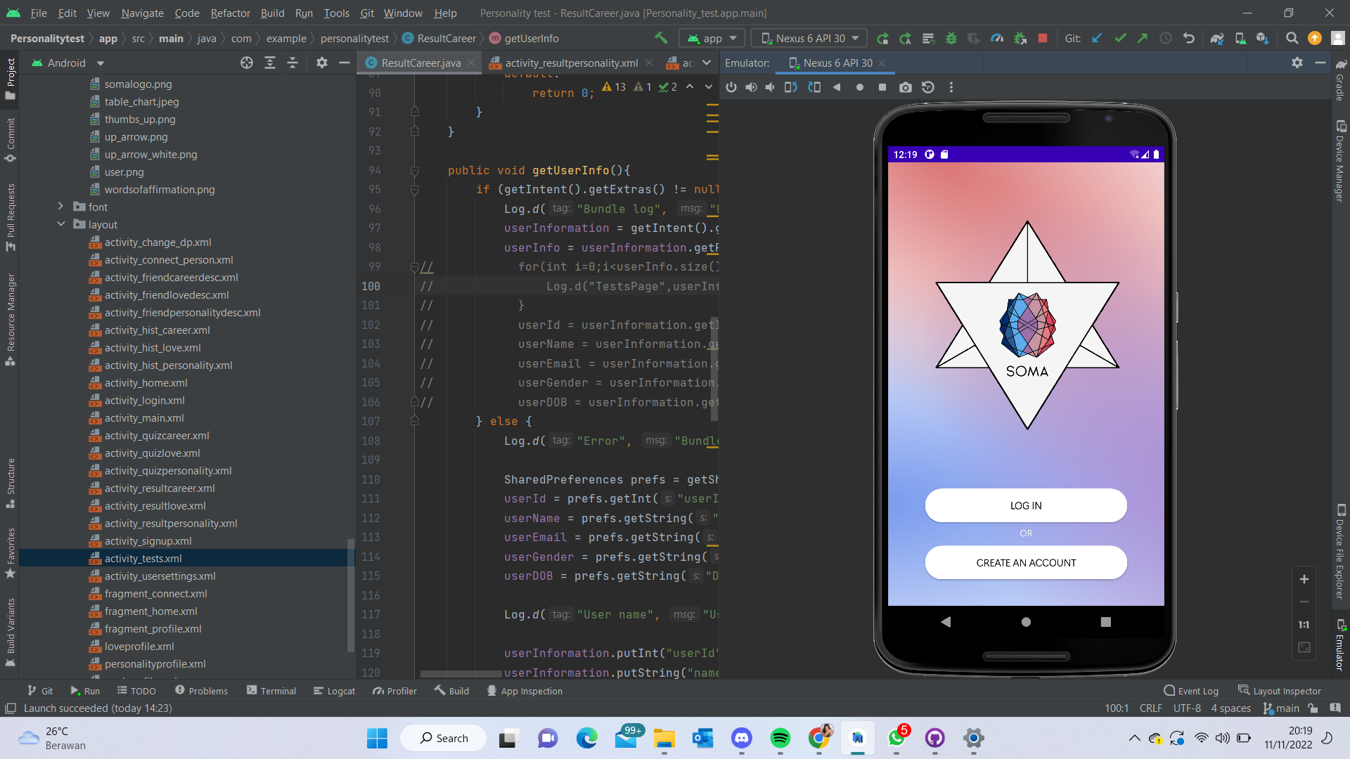 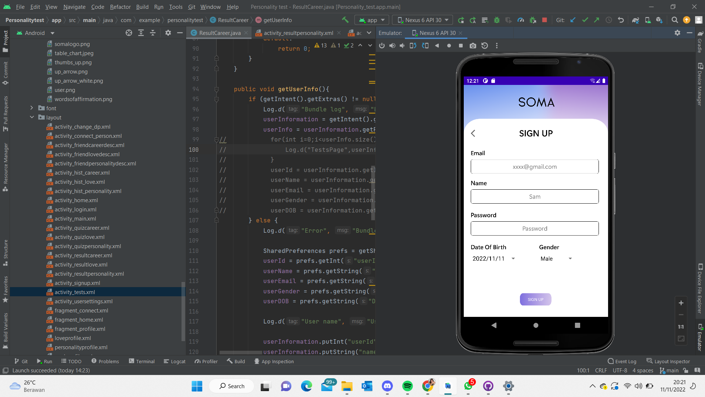 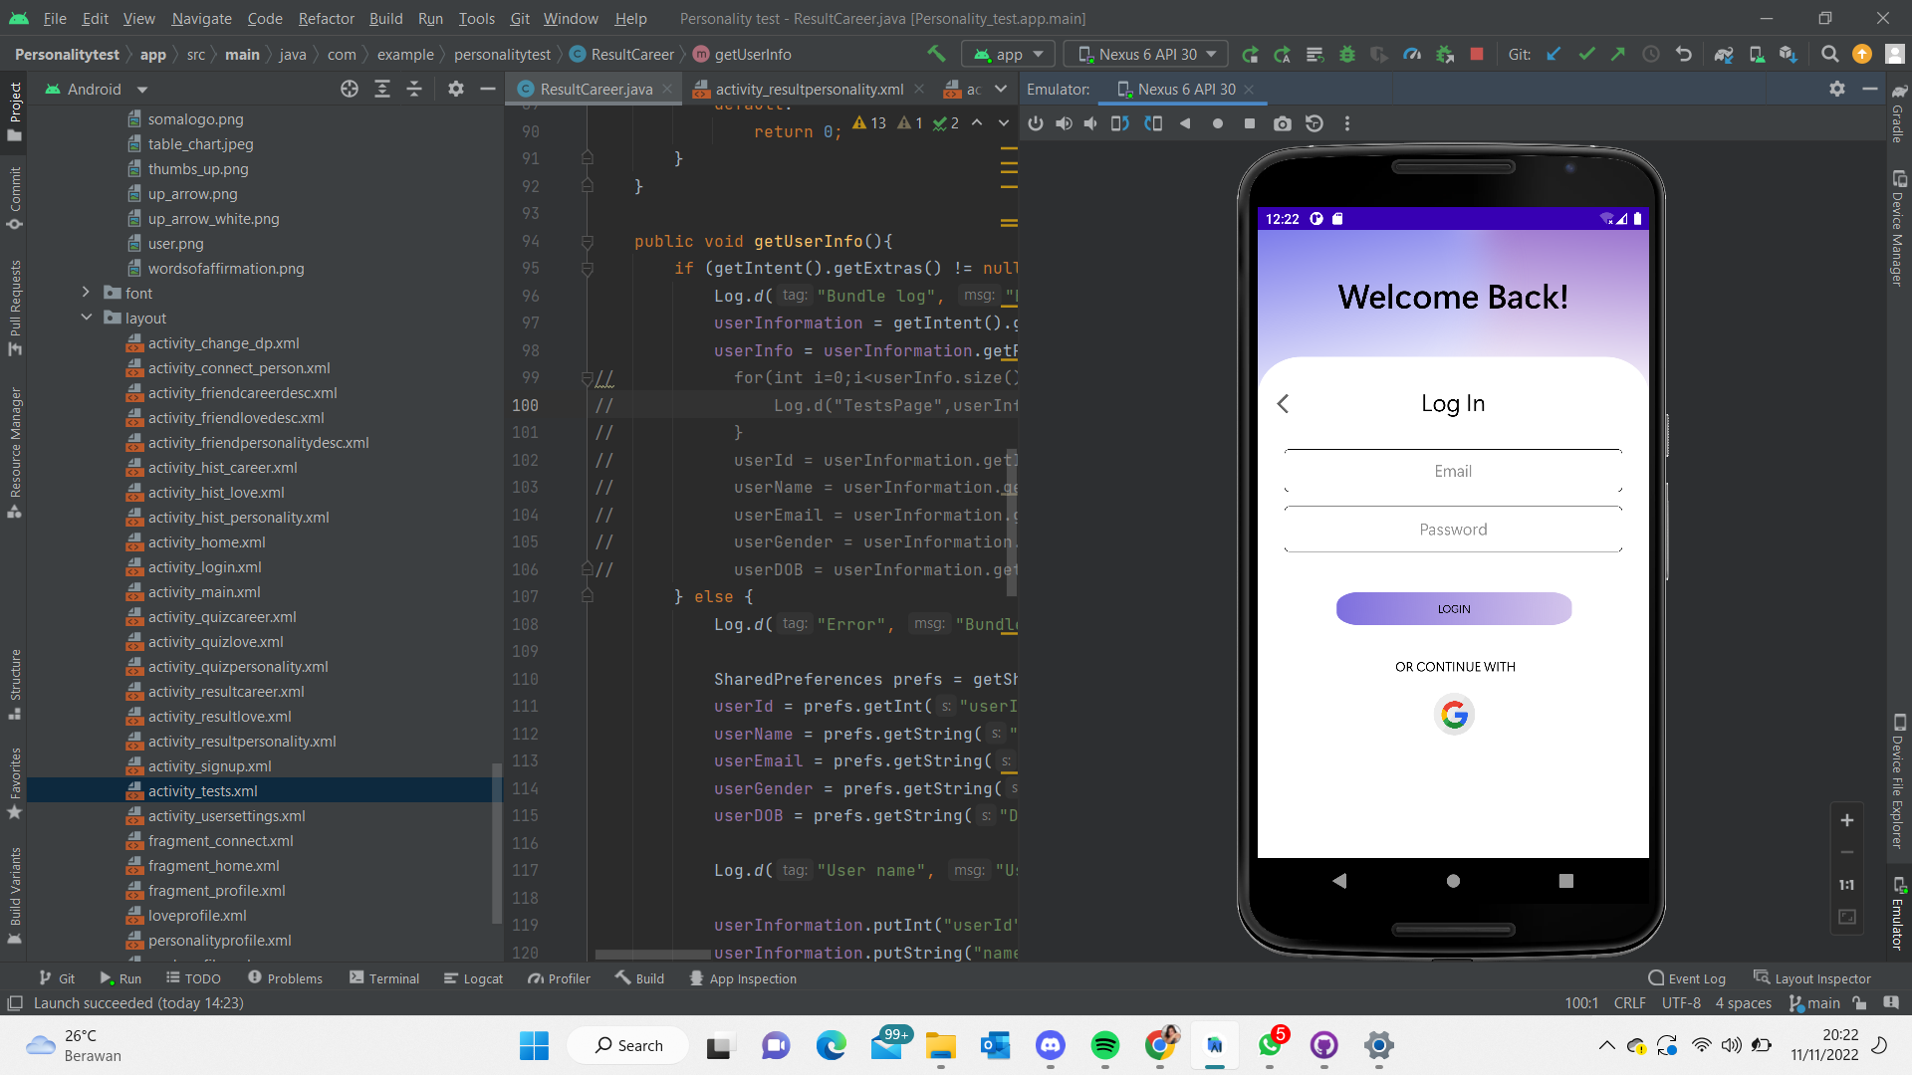

Fig 19. Log-In Pages

Before users began using our app, we requested their consent for a Data Privacy Disclaimer to make sure that the data obtained would only be used as permitted by law or with their consent and solely for the purposes of our app.

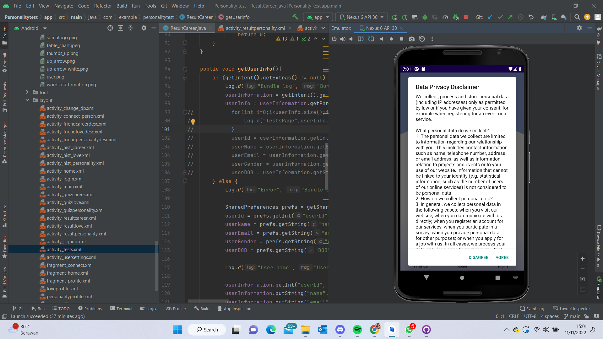 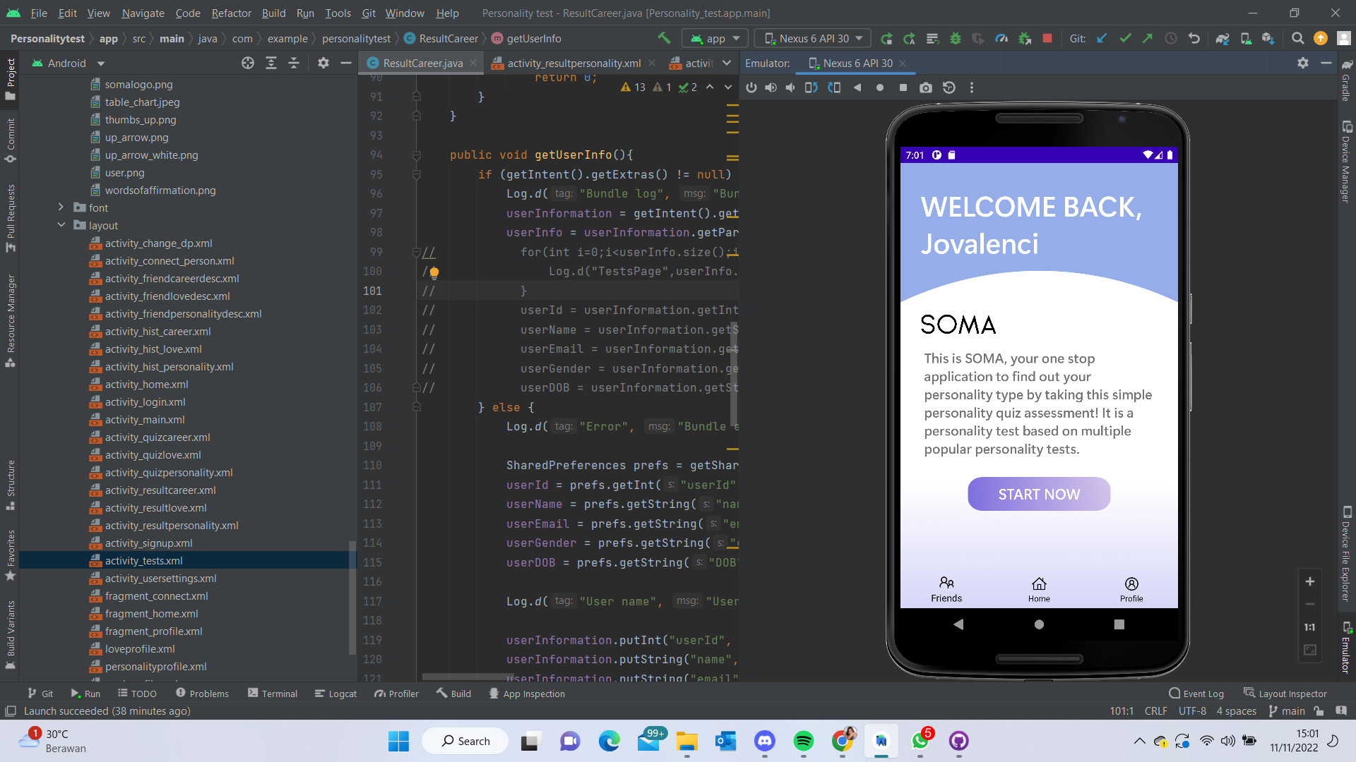

Fig 20. Home Page

After creating an account, our app gives users the option to change their personal information in the Profile - Settings Page. In case they decide not to use the app, users can log out of their account in this page as well.

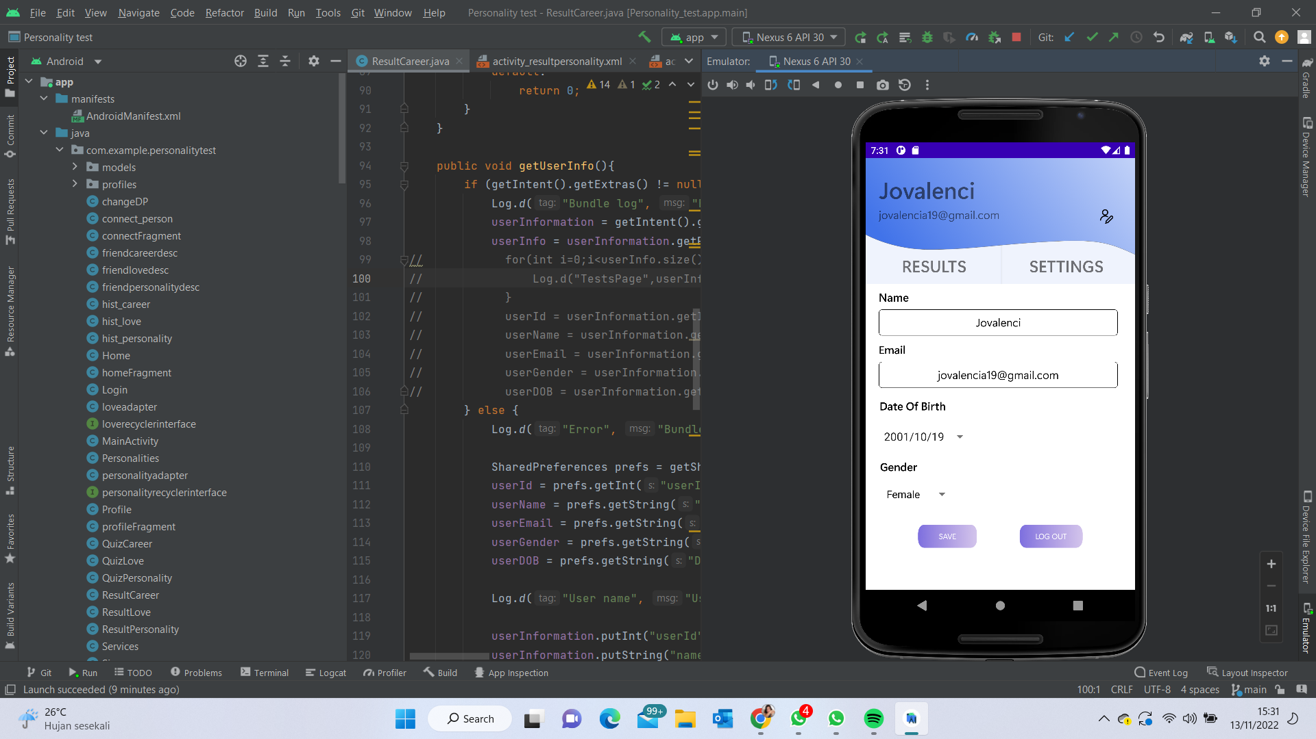

Fig 21. Profile Settings Page

Our team conducted research and created question banks with binary answers to attribute personality archetypes. We created the question bank based on research we conducted using tests that were already available online. Then, we broadened those inquiries to create new types of personality archetypes. In total, we managed to have 25 Personality, 10 Love, and 10 Career Test Questions. Figure 22 displays all of the Personality Archetypes that a user can acquire after taking the three tests we provided on our app.

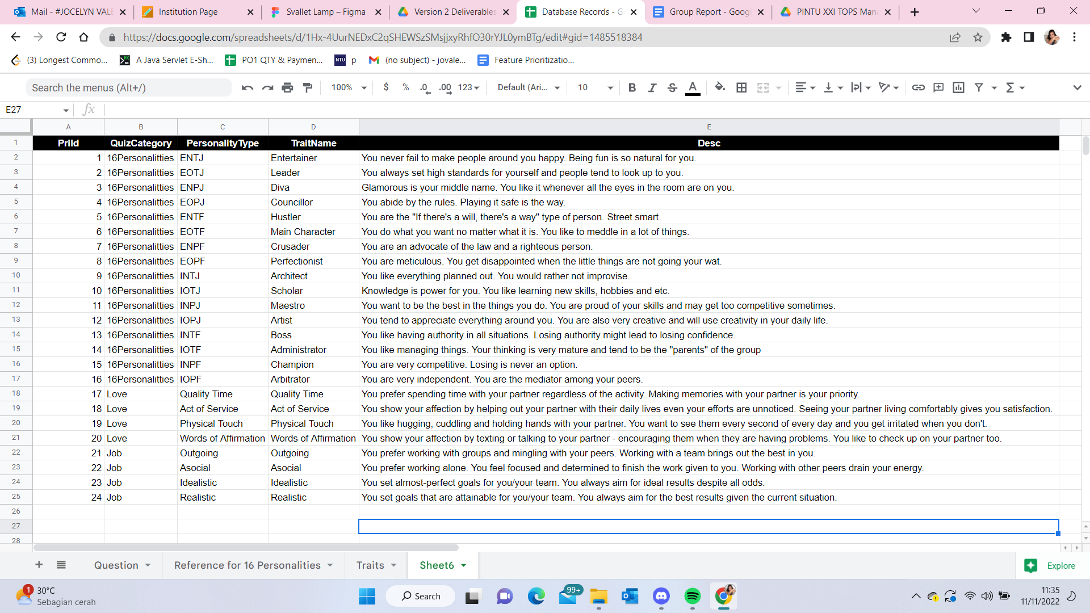

Fig 22. List of Personality Archetypes

At the end of each test, the players would also receive a unique avatar that our team has designed for the 20+ possible outcomes of their results. Avatars are visual representations of the traits, allowing users to understand their traits more easily. Each test will give an avatar. Fig 23 displays all possible visual representations of avatars that will be shown after taking the tests.

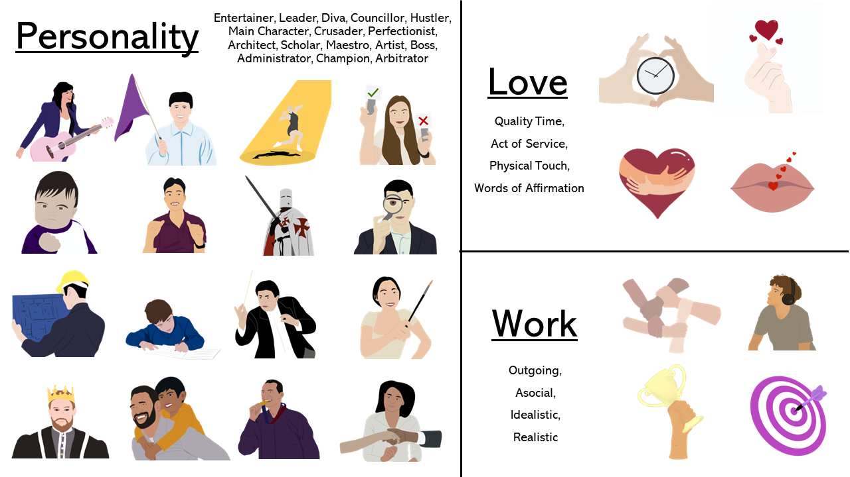

Fig 23. Visual avatars of Personality Archetypes

Upon the addition of having three different tests, the UI will have to change to be able to accommodate three different tests with simplicity. The results of the tests will have to be displayed together, thus we need to take into account the seamless transition from each test to the results display page of an individual.

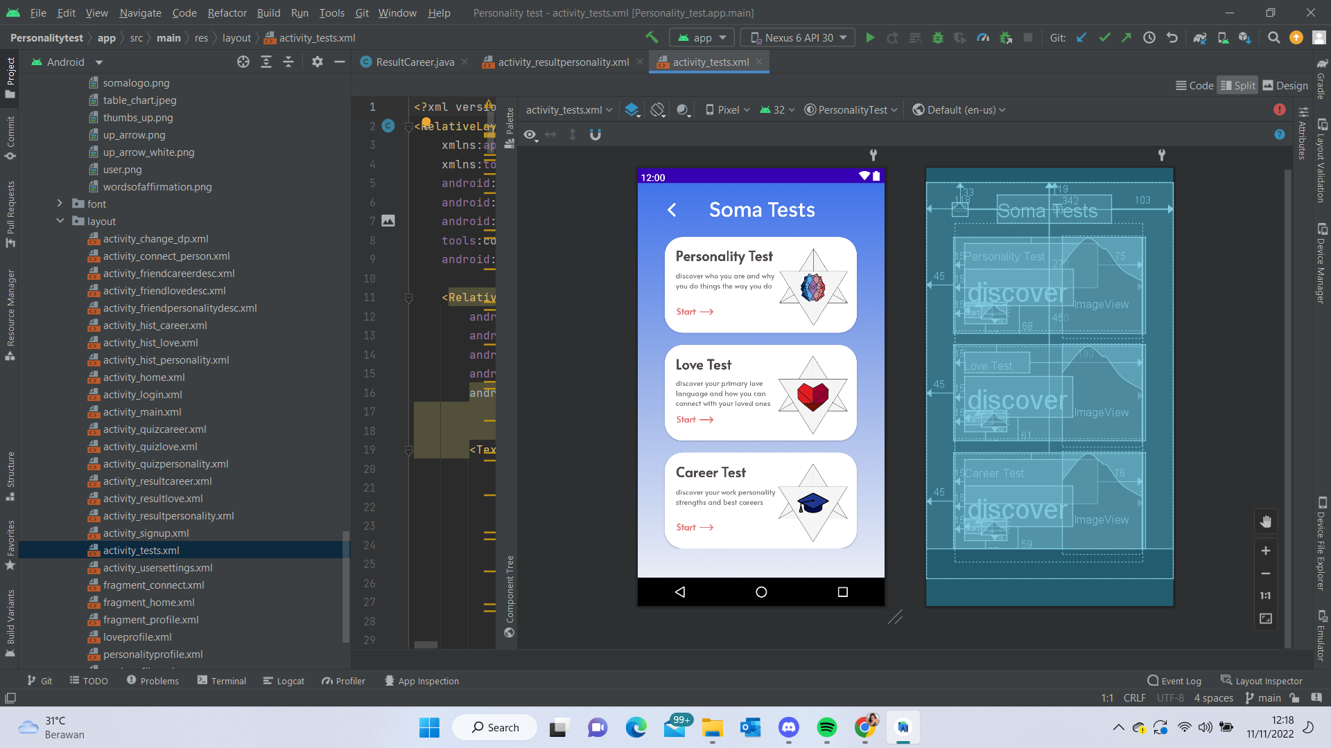 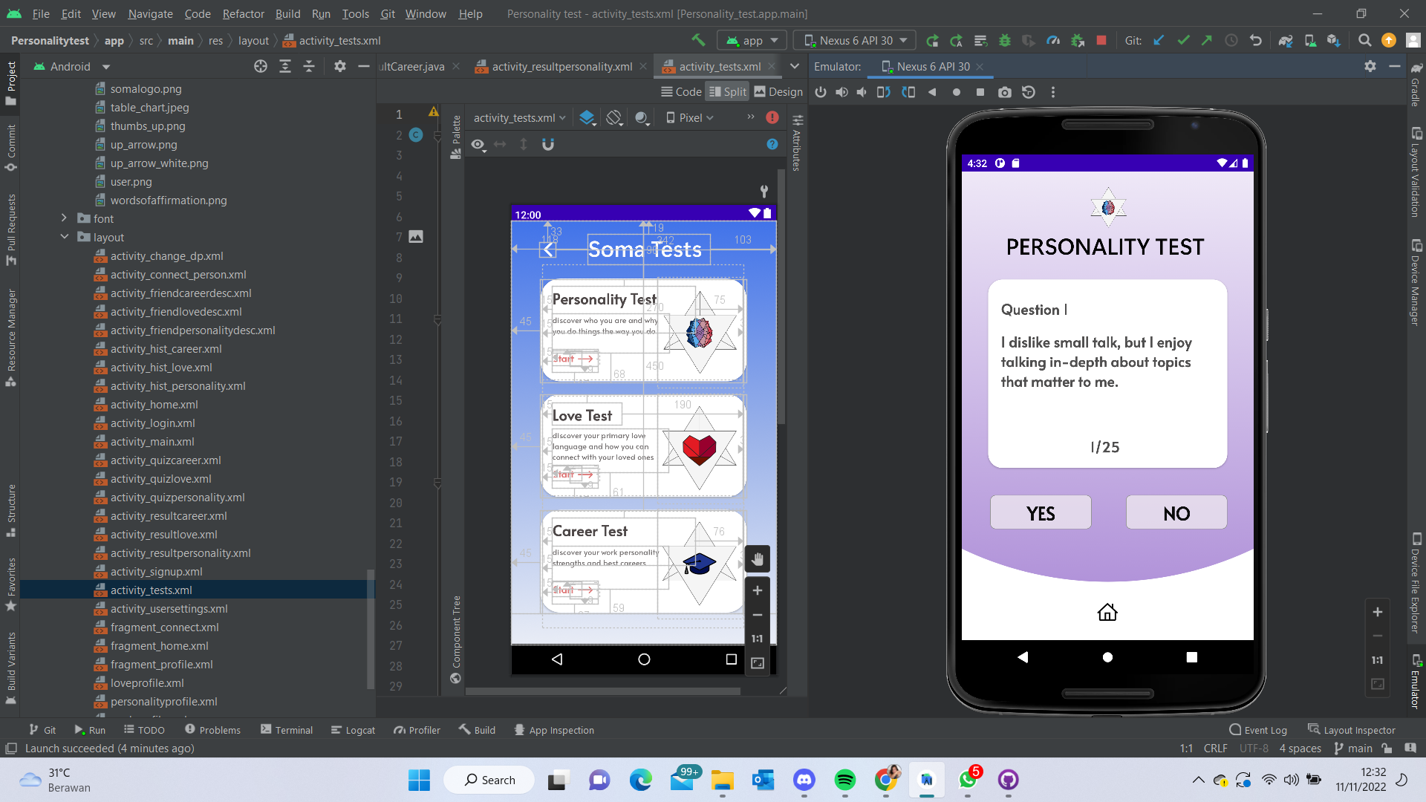 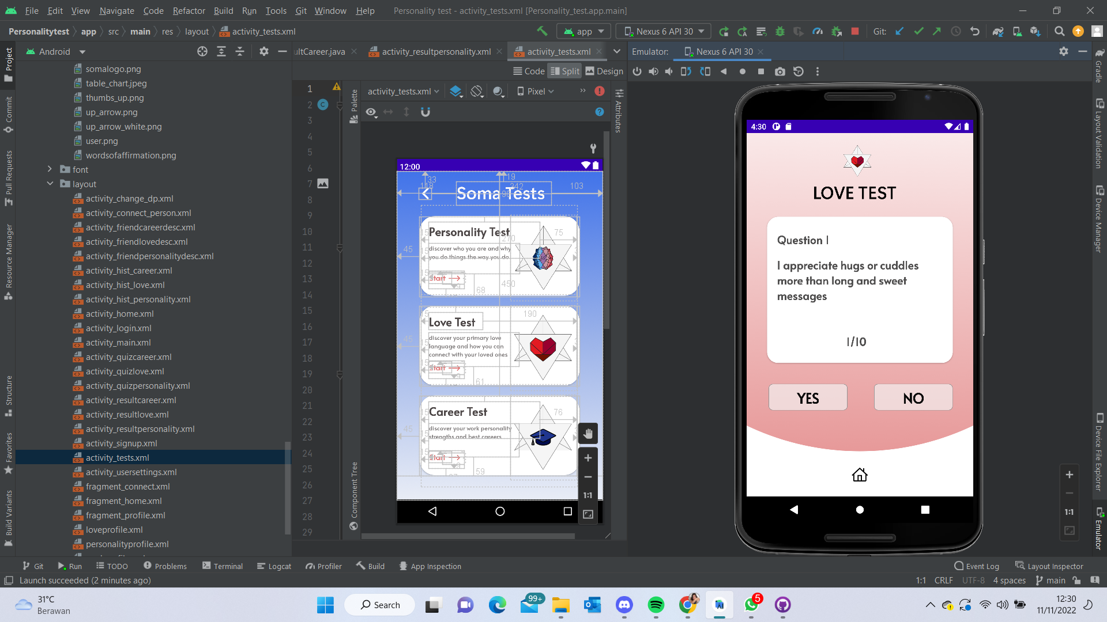 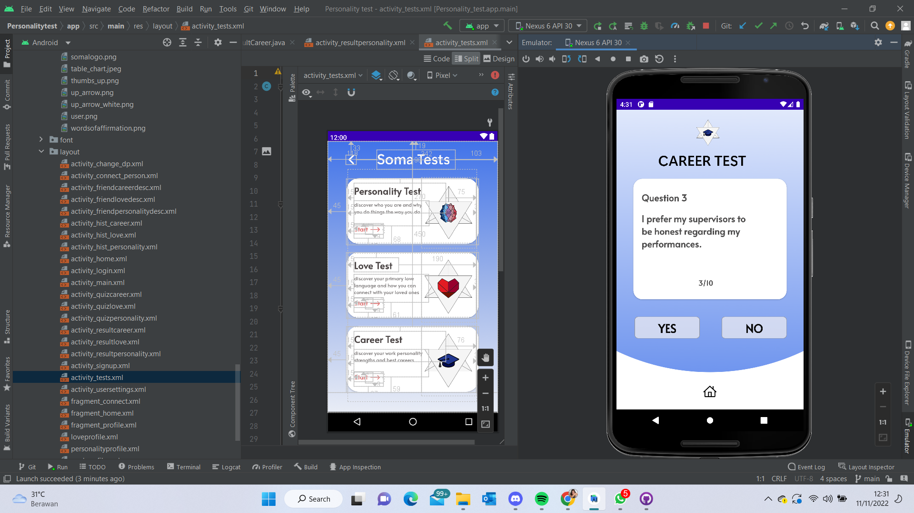

Fig 24. Tests Pages

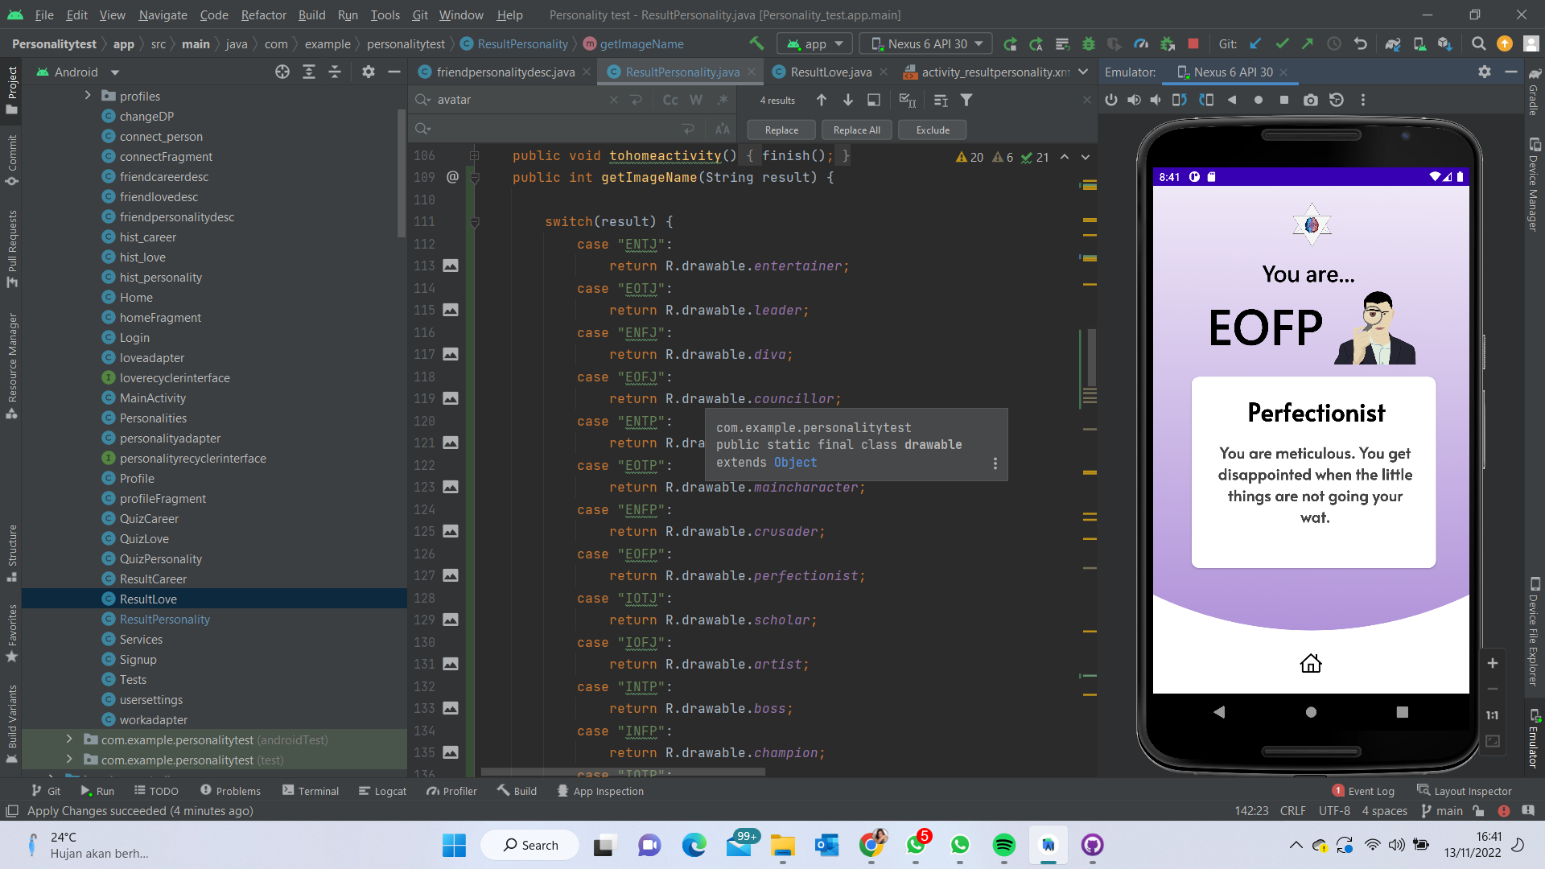 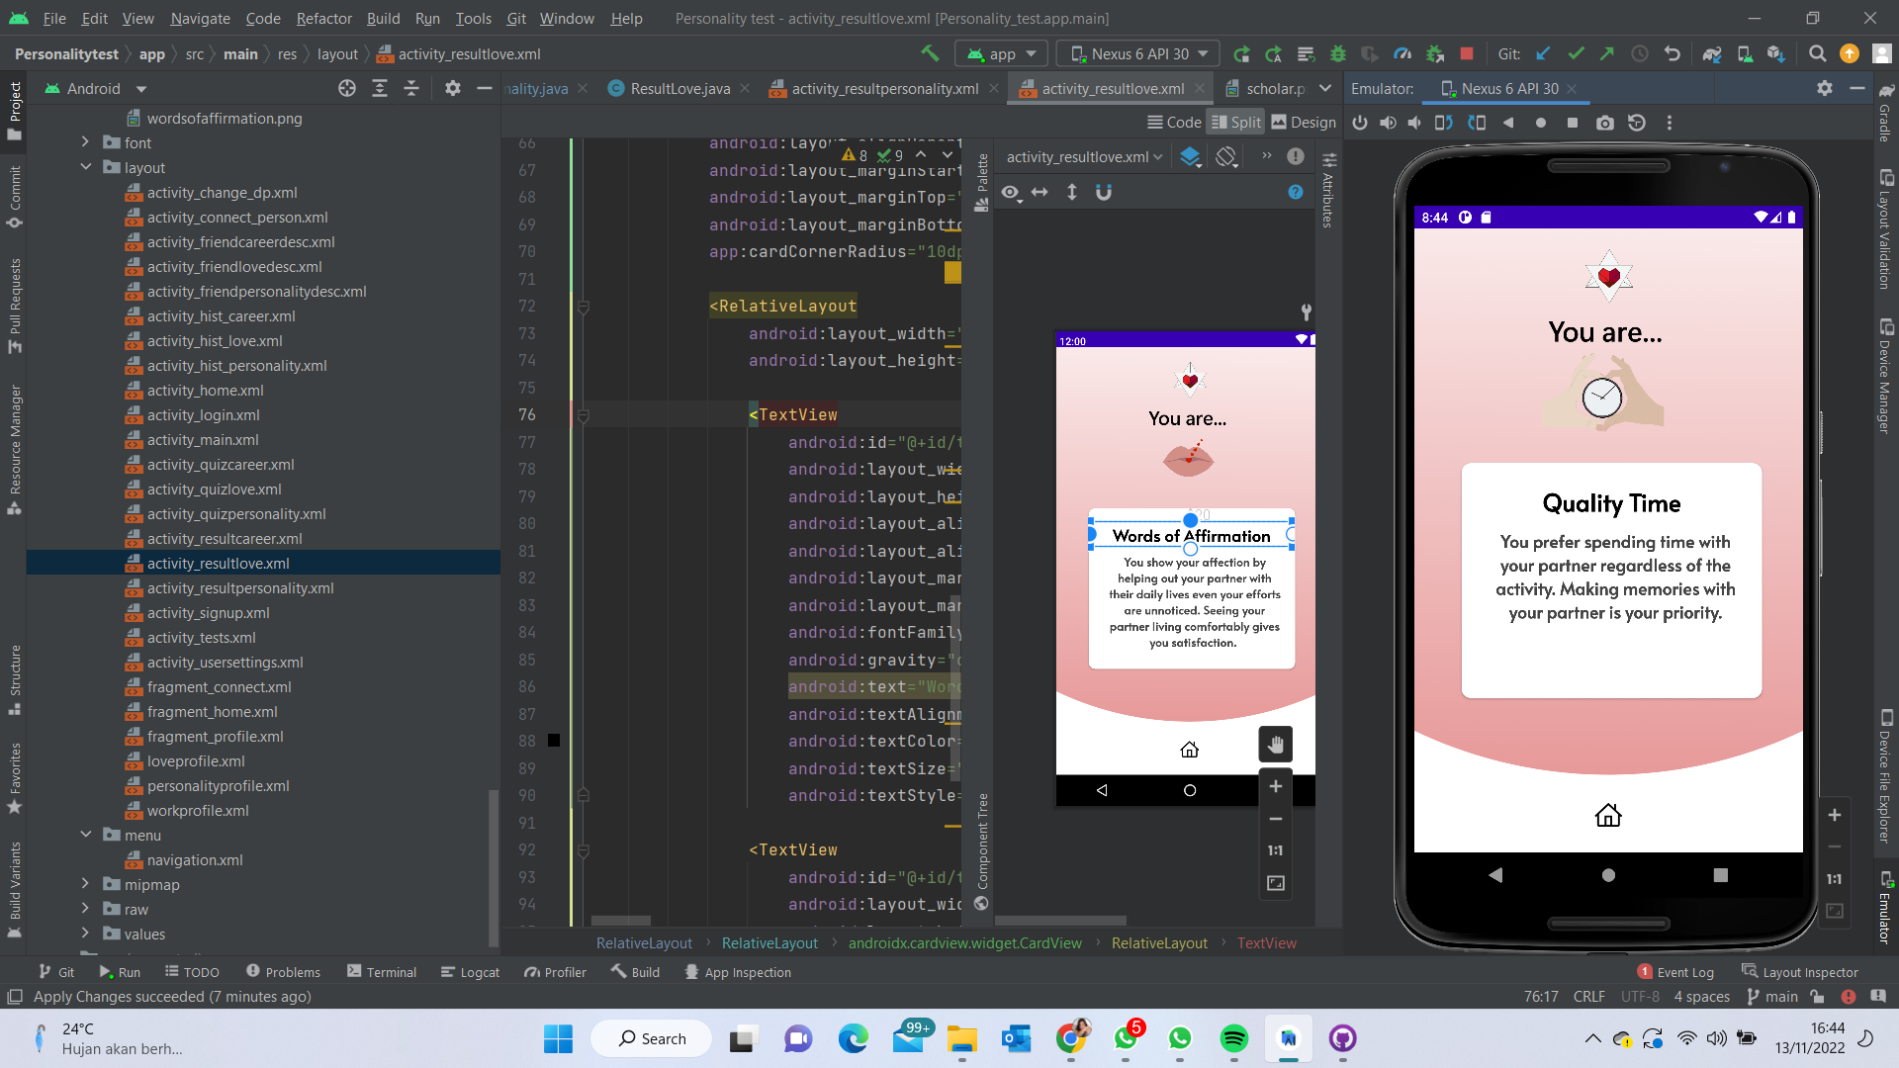 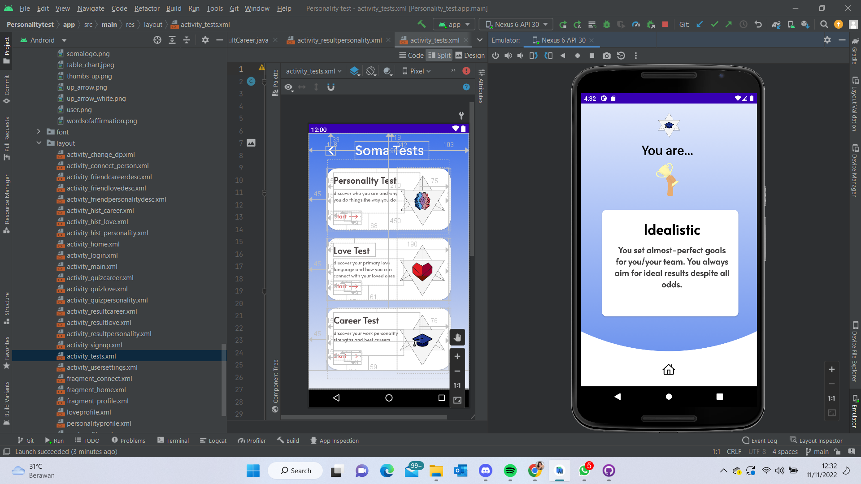

Fig 25. Results Pages

Due to the nature of our application to have an individual understand their traits, we deemed the feature of being able to access the history of their test results as necessary. To better organise the information, three separate pages were made for each test result.

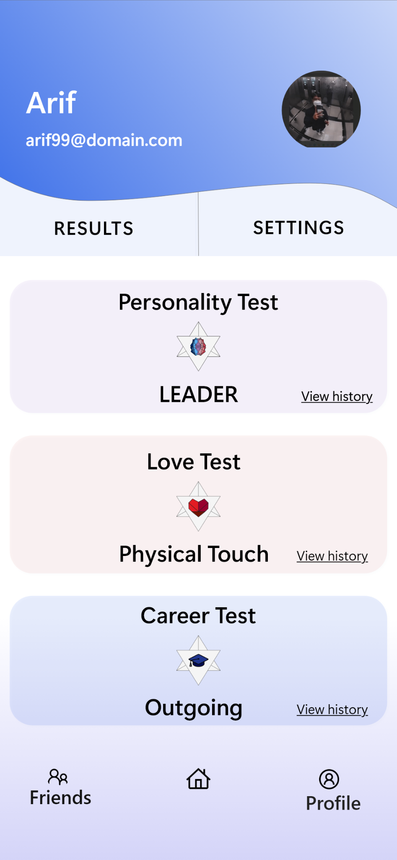 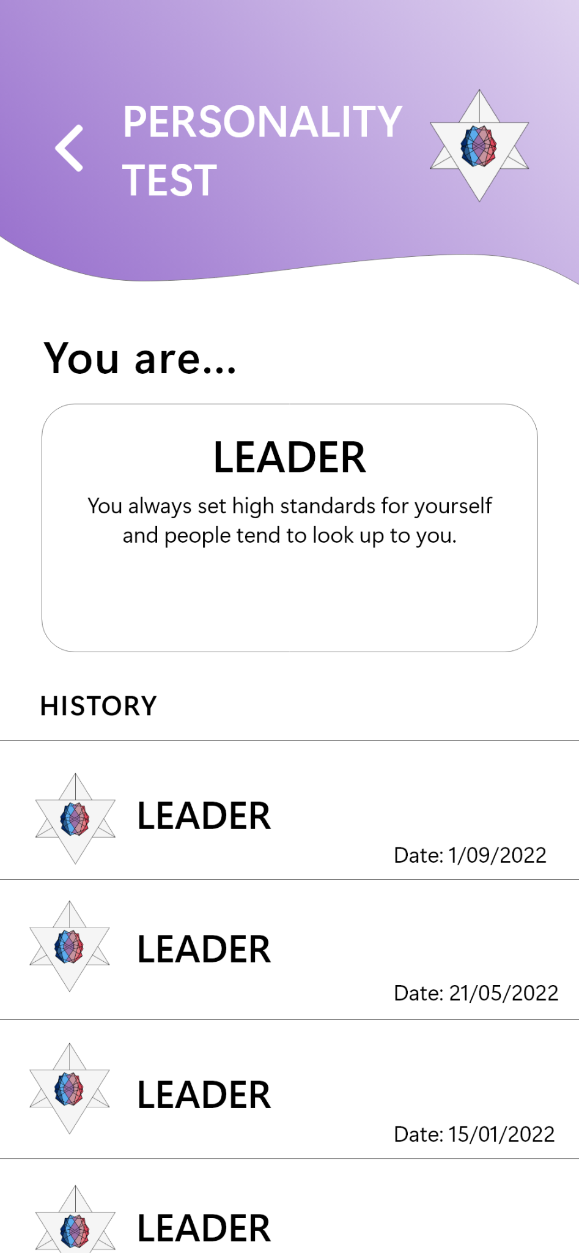 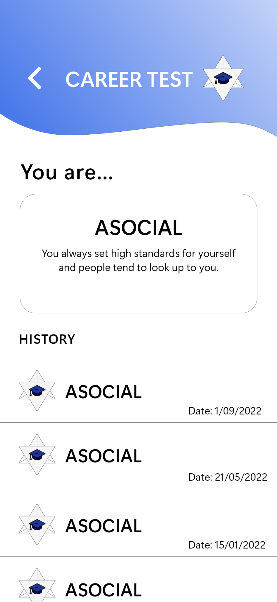 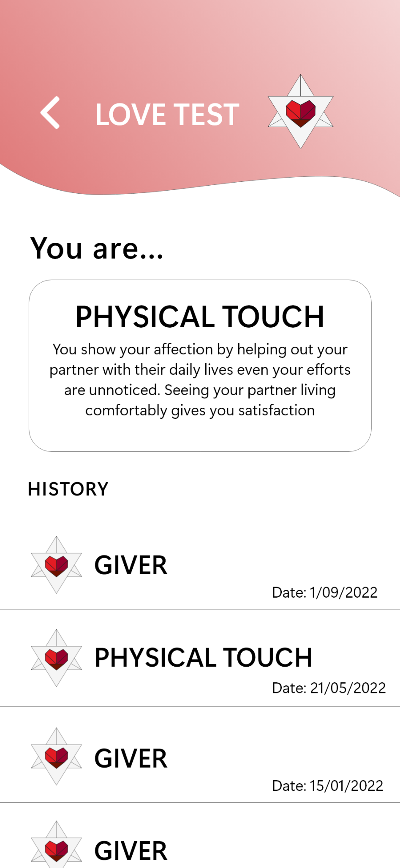

Fig 26. Result and History Pages

Moreover, our app has a Connect Friends Feature, where users can broaden their network and find new pals that have similar traits after taking the tests provided by our app. Users who haven't taken the tests won't see friends. The user can also view the profiles of other users to determine whether their profiles align.

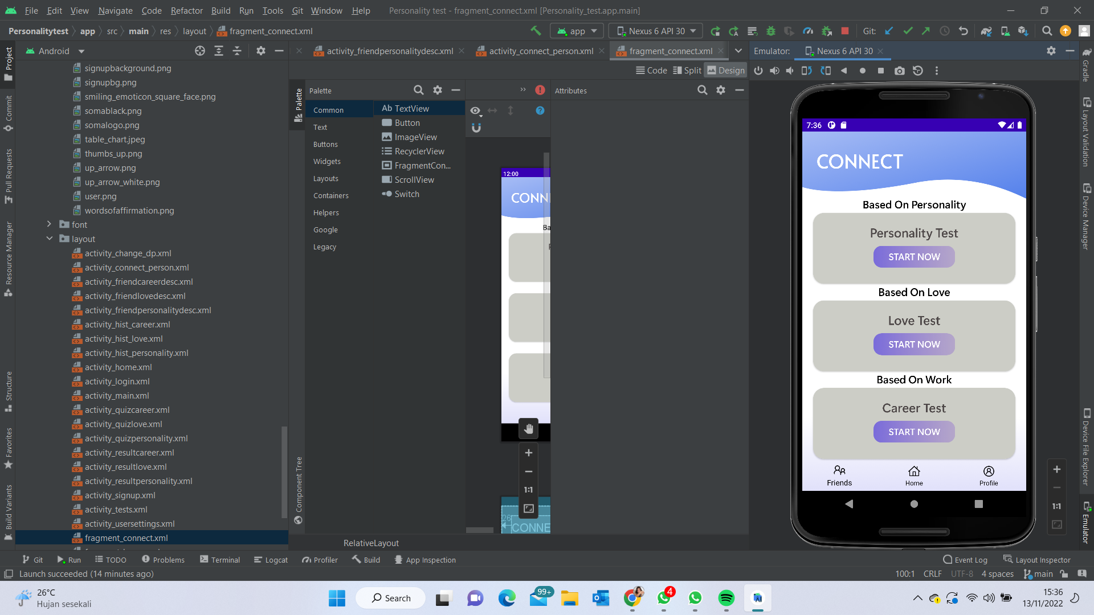 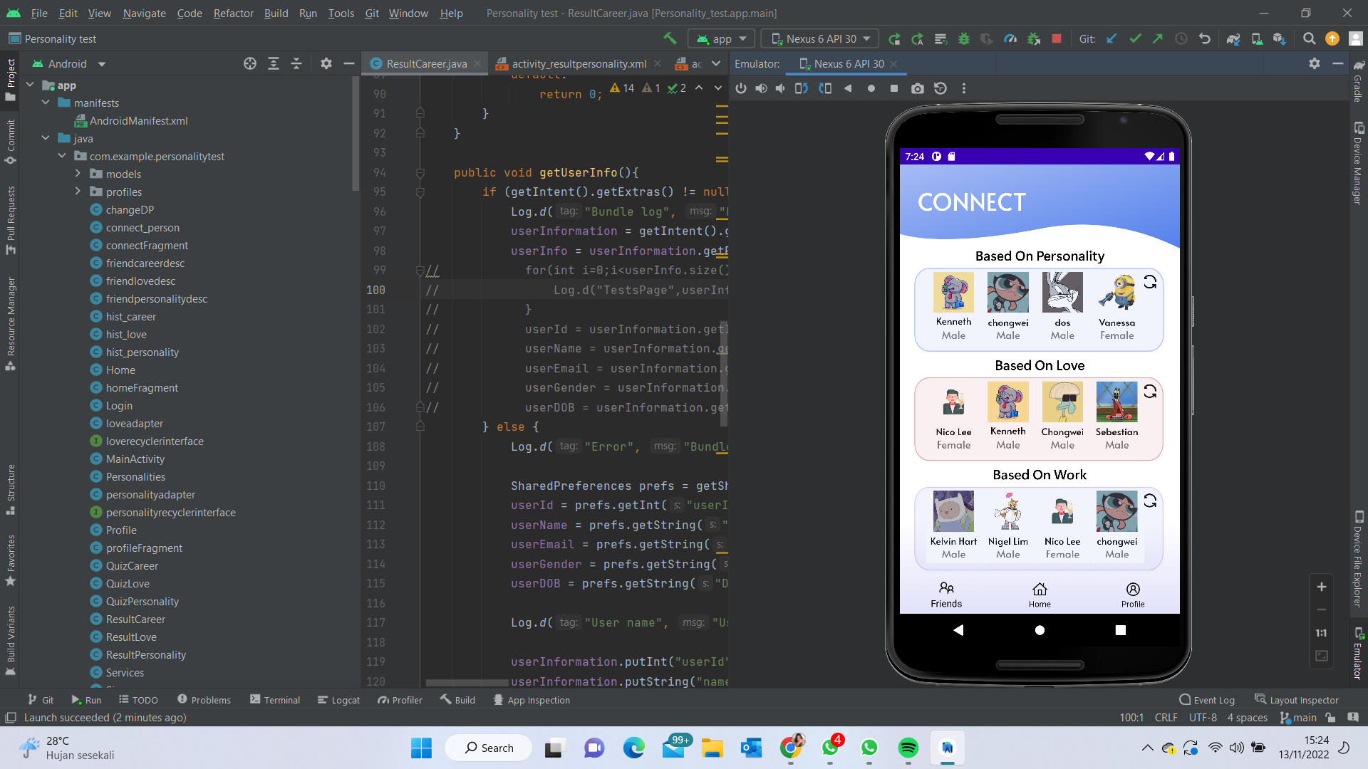

Fig 27. Connect Friends Page

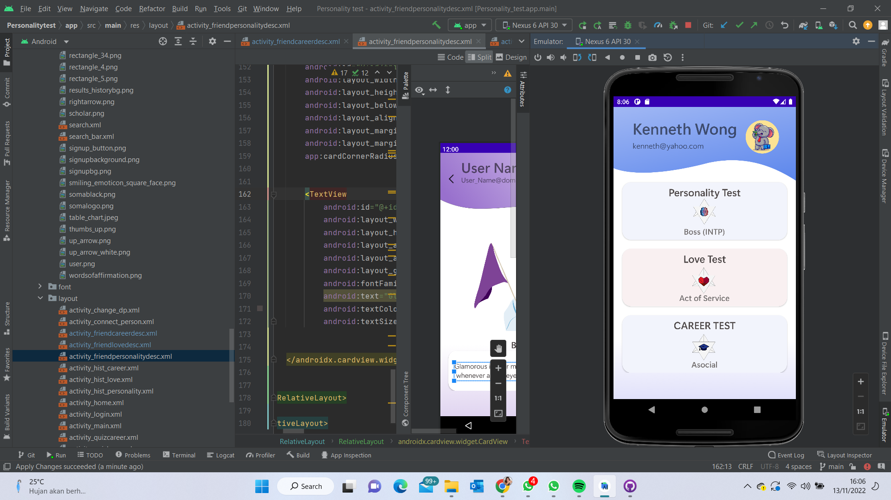 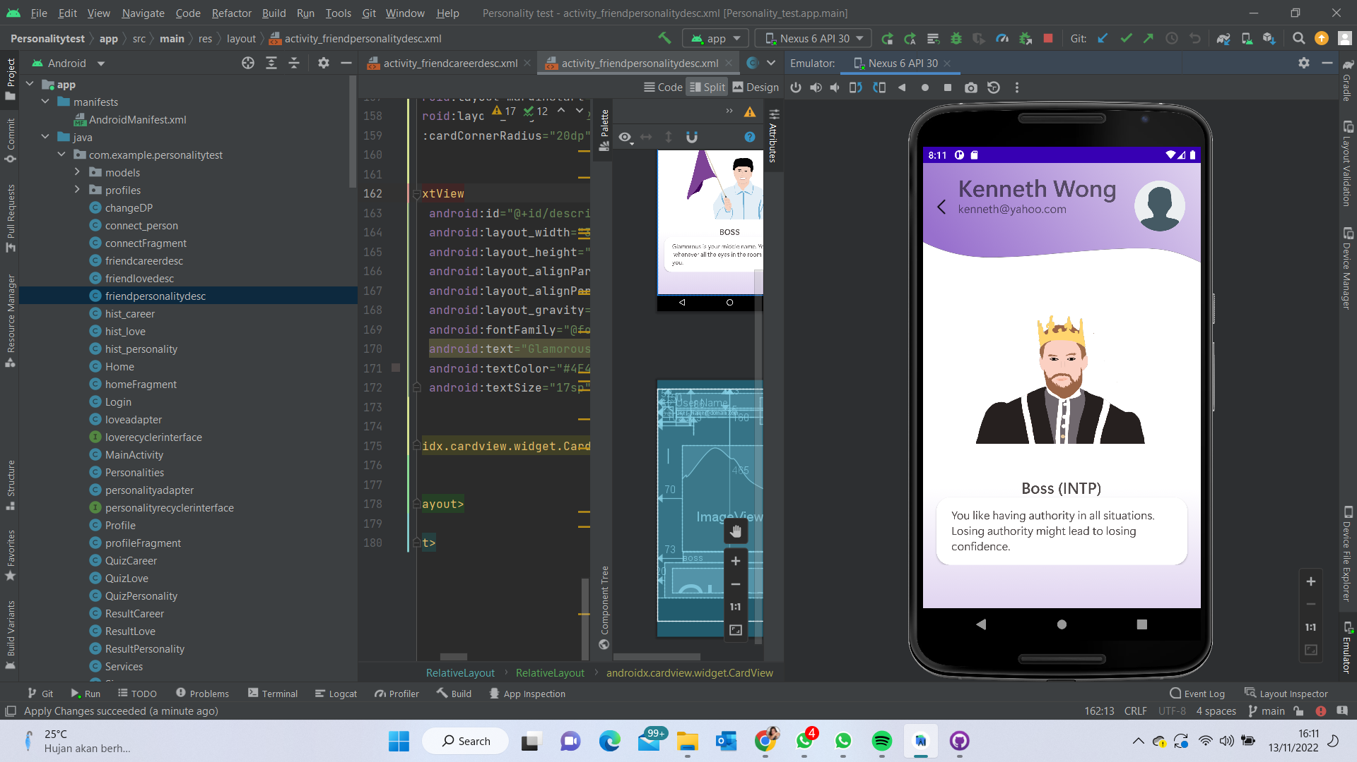 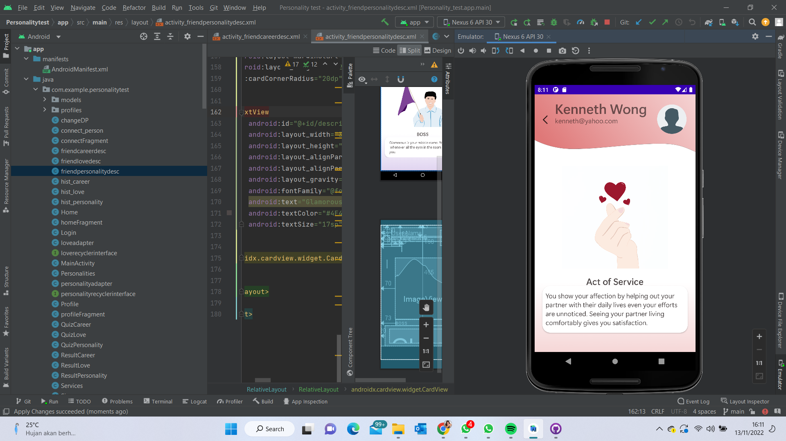 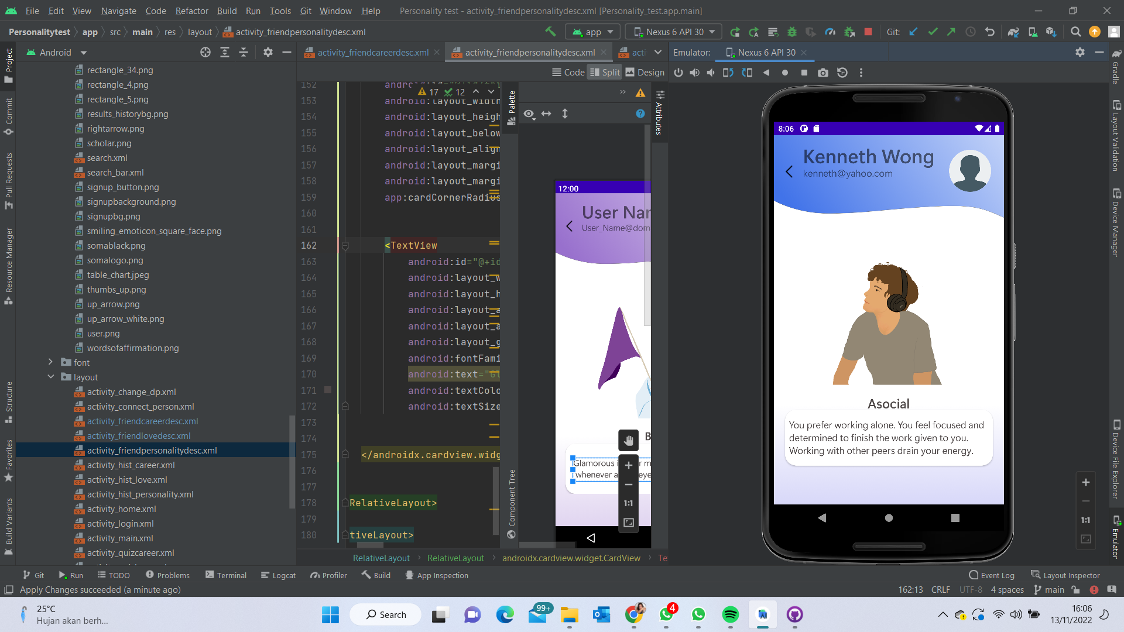

Fig 28. Friend’s Profile Pages

# 

# **Conclusion and Recommendation**

Our team set out to design a personality test software and achieved this goal. In doing so, we were able to create something unique and learn many skill sets outside of our academic curriculum. We have come a long way since the beginning of our project and have learnt many meaningful lessons along the journey.

We also recognise that it is important to reflect upon our design process and give recommendations towards what could be improved and done better. We observed from other on-going software projects that some of our software technologies may prove outdated in modern mobile app development. Had we chosen to develop using React Native framework for instance, we would have been able to test the software more easily on different mobile platforms, as well as access to better UI design schemes for a further range of design options.

For additional feature enhancements, we can add a suggestion tool that will introduce SOMA members to new interests, pastimes, or locales based on the test results that best suit their personalities. Additionally, a notification system can be introduced to keep users informed about the most recent services offered by the SOMA App.

# 

# 

# 

# **Appendices**

1. Product Requirement Document

Link: <https://bit.ly/ProductRequirementDocument>

1. Product Pitch Document

Link: <https://bit.ly/ProductPitchDocument>

1. Source Code (Github Repository)

Link: <https://github.com/chongwei49/DIP-Group-6-Android>

1. Project Video

Link: <https://tinyurl.com/DIP-Group6>

1. Presentation Deck

Link: <https://tinyurl.com/DIP-G6-Slide>

1. Project Poster (Promotional & Functional)

